**BIS 425**

**Information Systems Development Project**

Johnson’s Seasonal Care

Due Date: April 17, 2016

By: Thomas Porter, Amber Johnson, Donghwan Kim, Ryan Grysen, Jake Enders



**CONTENTS**

1. **Screen Views**
   1. Home – pg. 3
   2. Login – pg. 4
   3. Users – pg. 5
   4. Customers – pg. 8
   5. Equipments – pg. 12
   6. Services – pg. 16
   7. Contracts – pg. 20
   8. Work – pg. 24
   9. Invoices – pg. 27
2. **Code Views**
   1. Module 1 – pg. 31
   2. Login – pg. 33
   3. Home – pg. 34
   4. Users – pg. 36
   5. Customers – pg. 43
   6. Equipments – pg. 49
   7. Services – pg. 54
   8. Contracts – pg. 59
   9. Work – pg. 66
   10. Invoices – pg. 69
   11. Invice Report – pg. 71

**SCREEN VIEWS**

* **Home**
  1. Home Design View

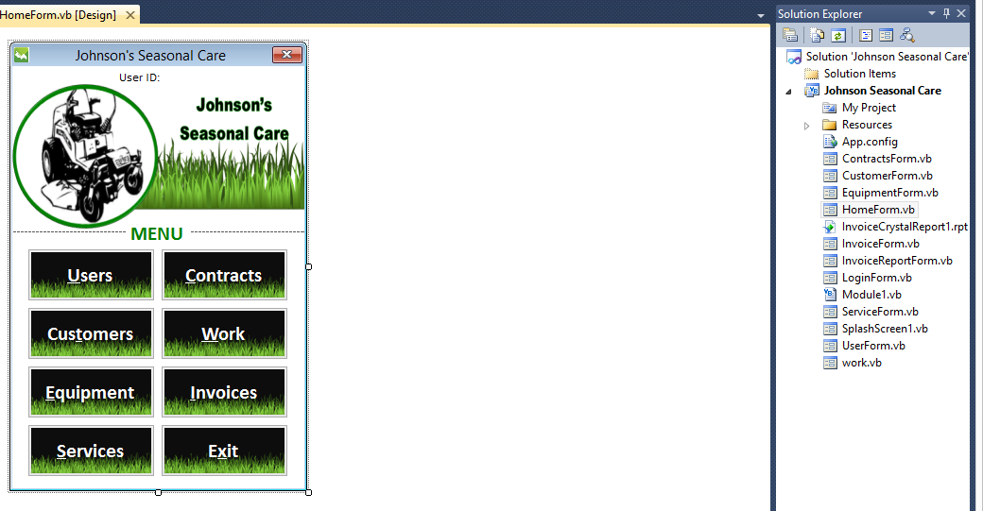

* 1. Execution View

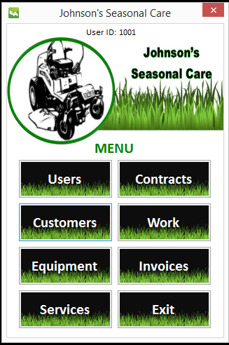

* **Login**
  1. Login Design View

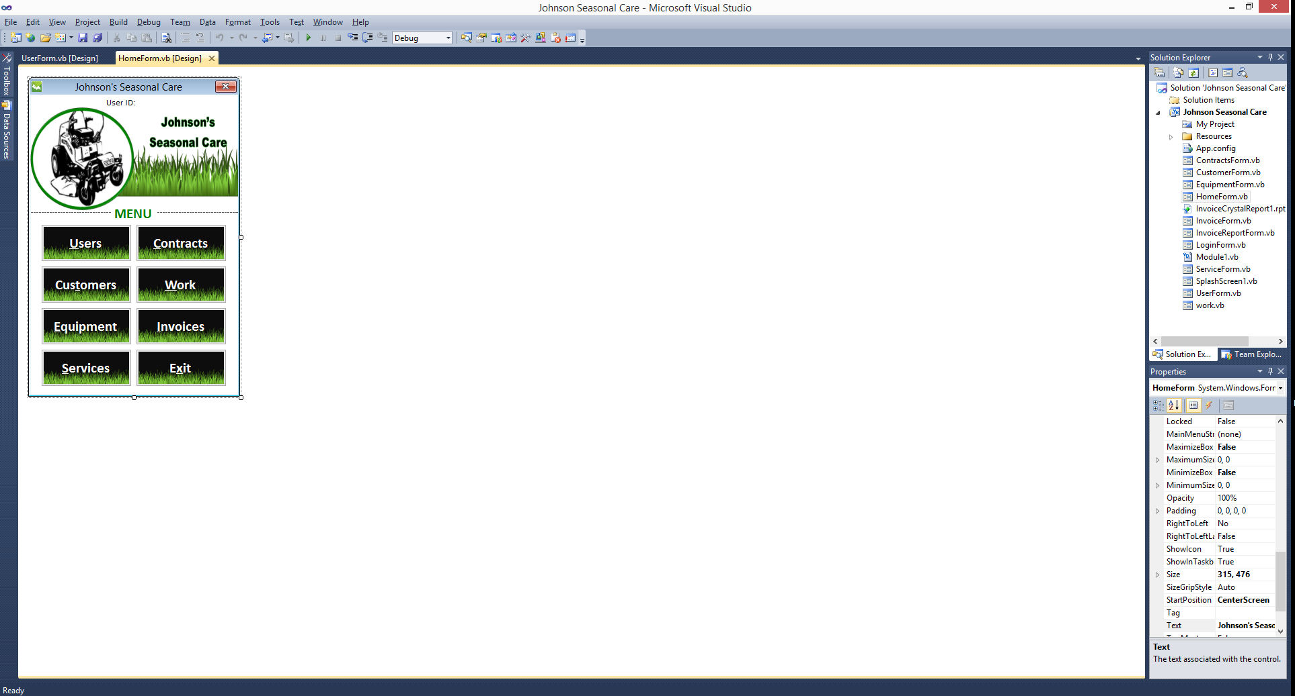

* 1. Execution View

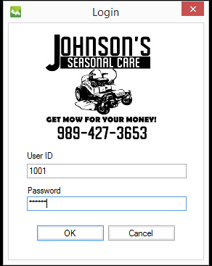

* 1. Wrong log in information is entered and “OK” button is clicked.

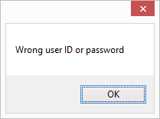

* **Users** 
  1. User Design View

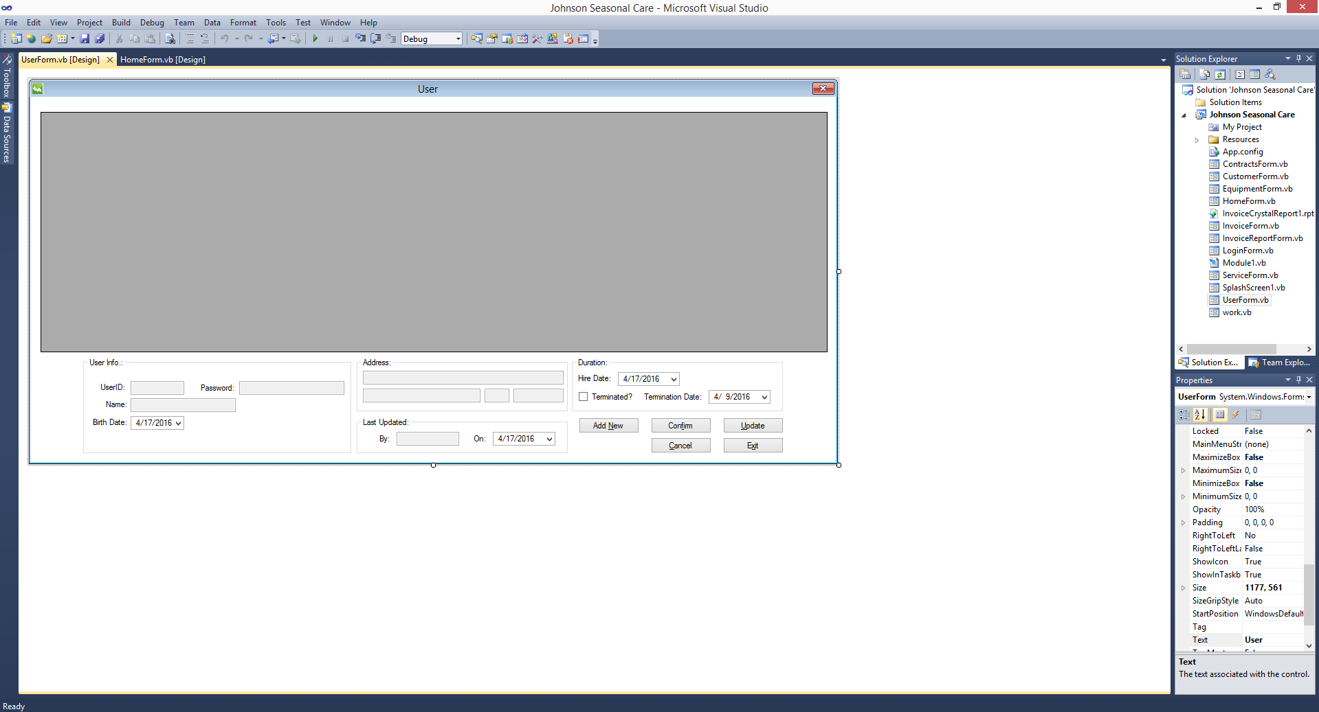

* 1. Execution View

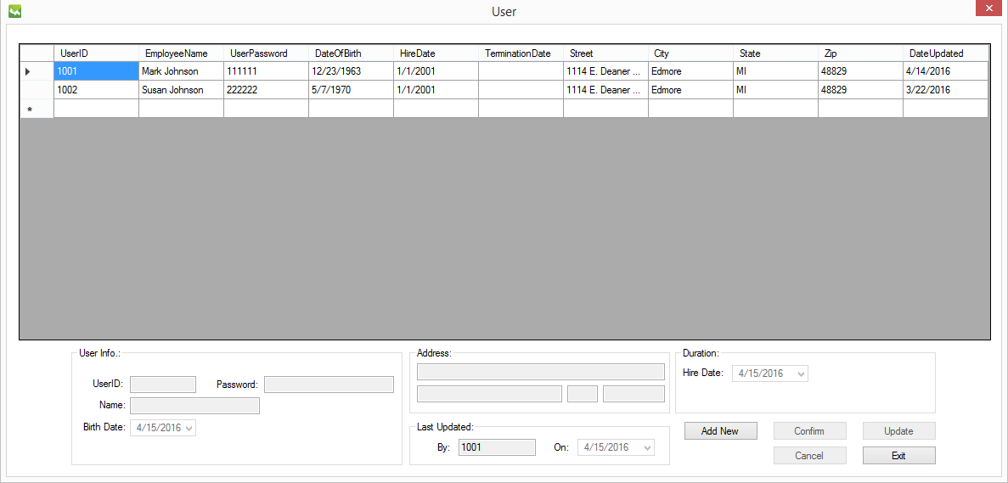

* 1. “Add New” button is clicked.

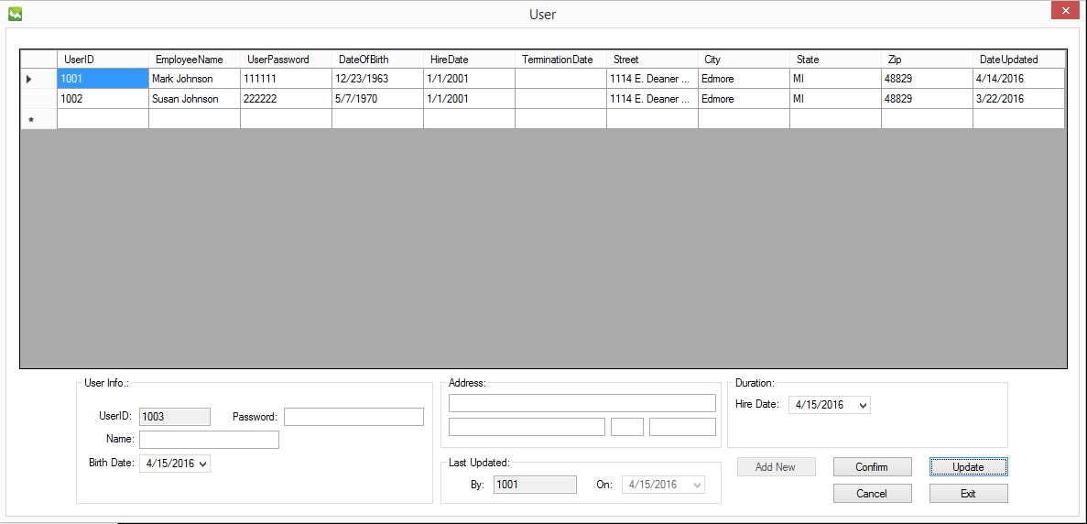

* 1. “Confirm” Button is Executed

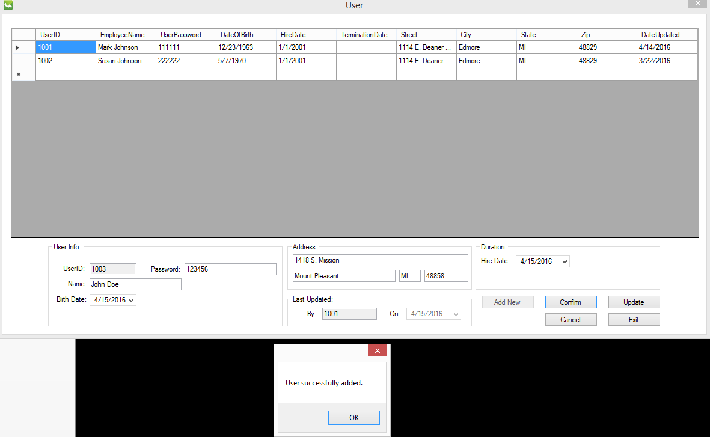

* 1. “Update” button is clicked.

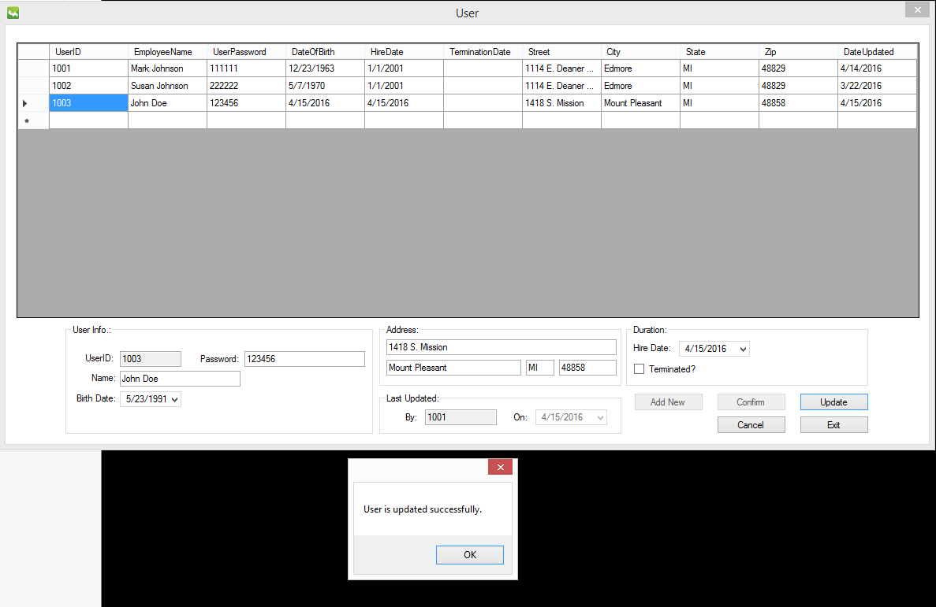

* 1. “Exit” button is clicked.



* **Customers** 
  1. Customers Design View

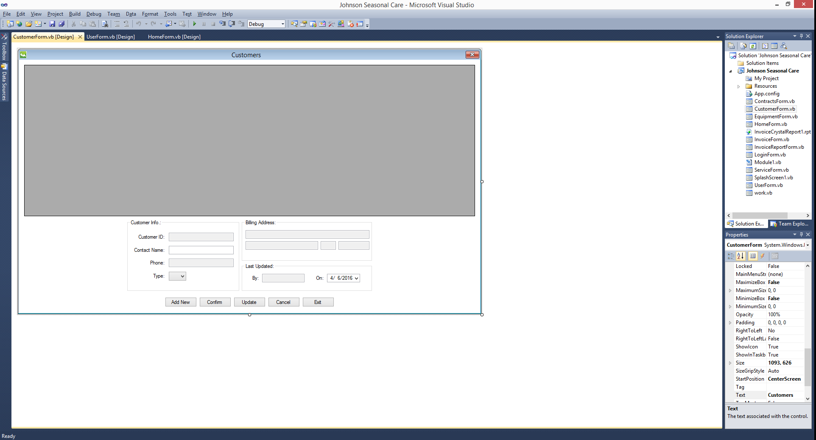

* 1. Execution View

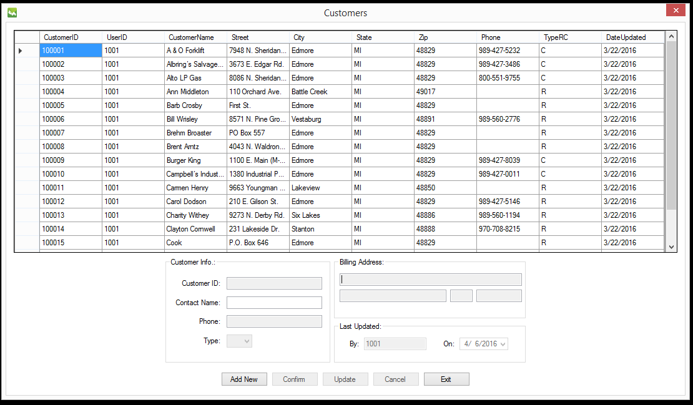

* 1. “Add New” Button is clicked.

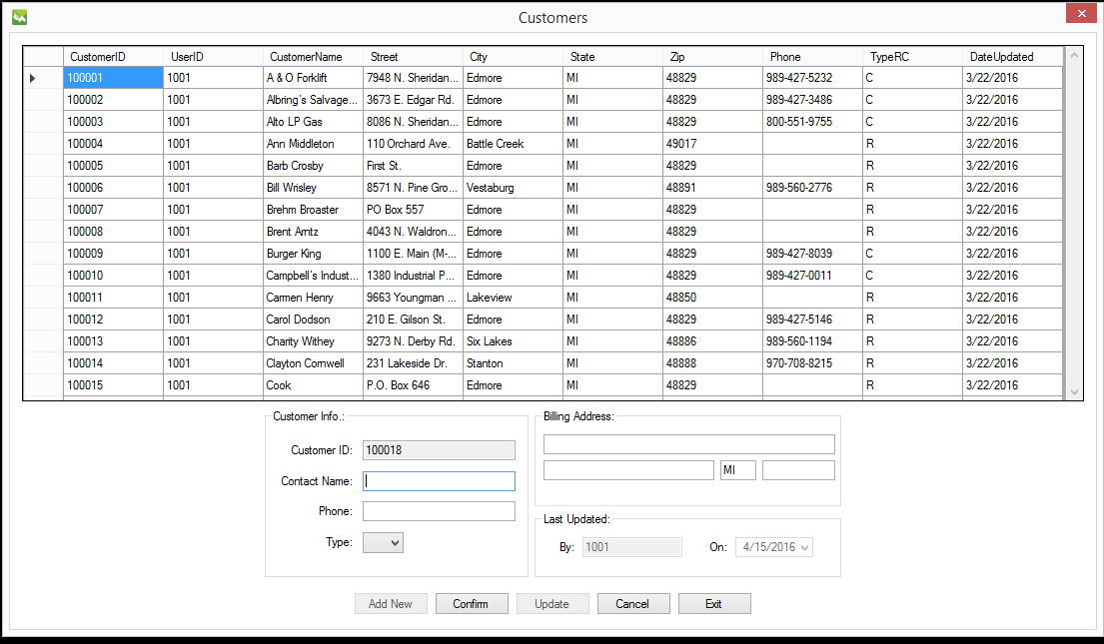

* 1. “Confirm” Button is clicked.

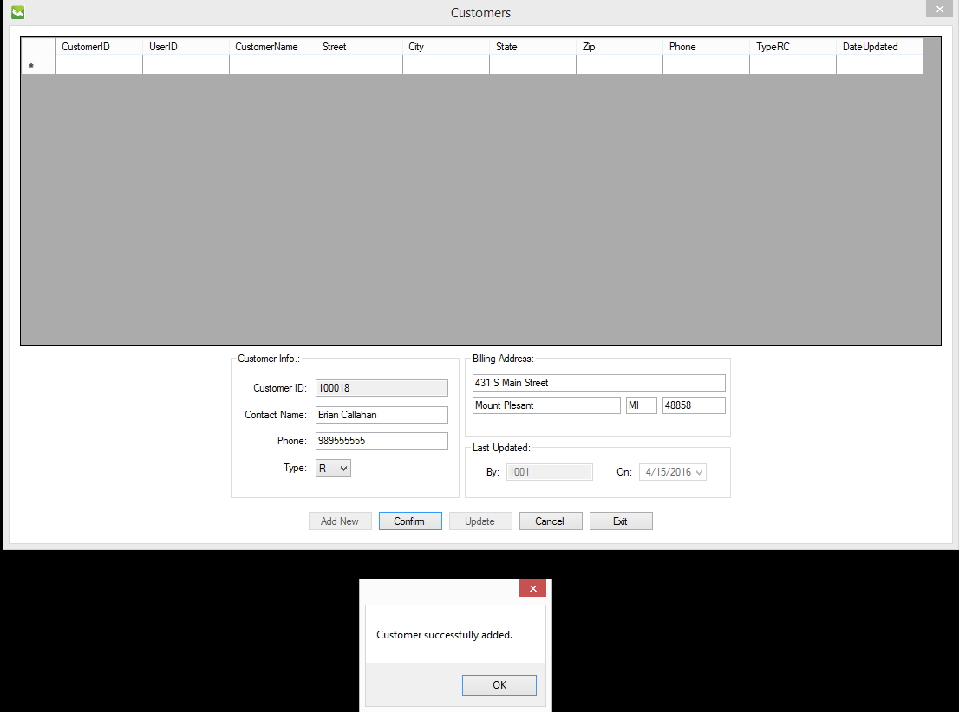

* 1. “OK” button is clicked.

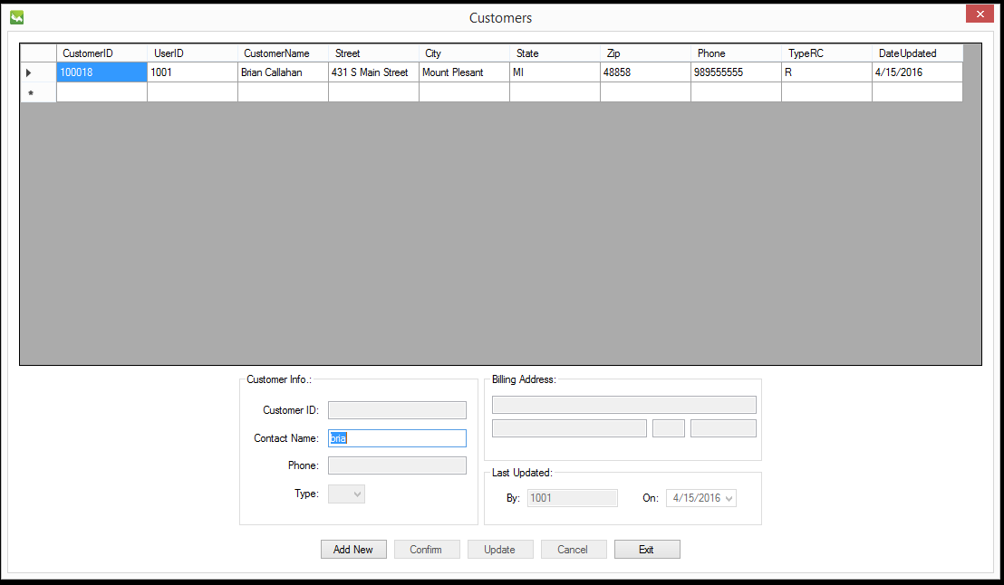

* 1. “Update” Button is clicked.

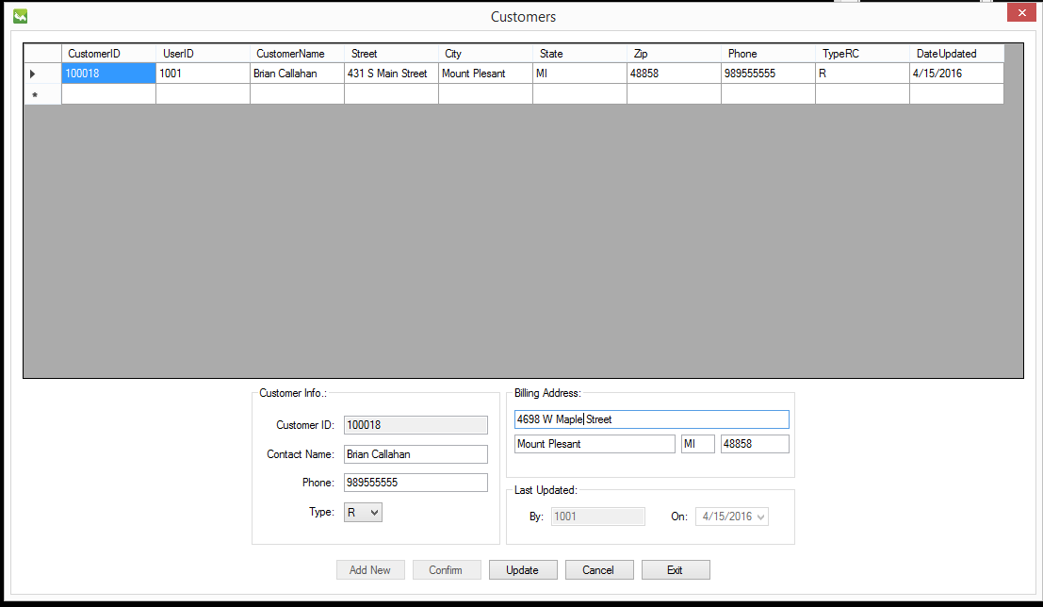

* 1. “Confirm” button is clicked.

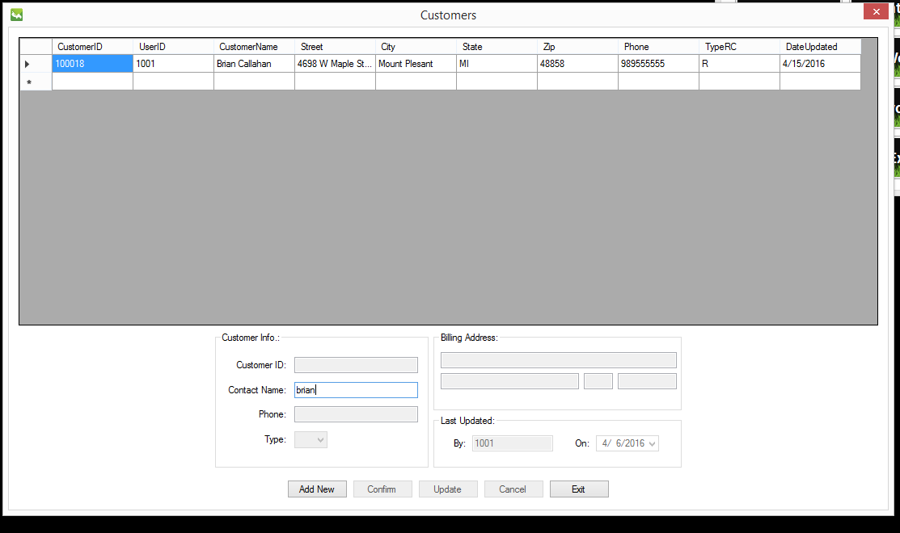

* 1. “Exit” Button is clicked.



* **Equipment** 
  1. Equipment Design View

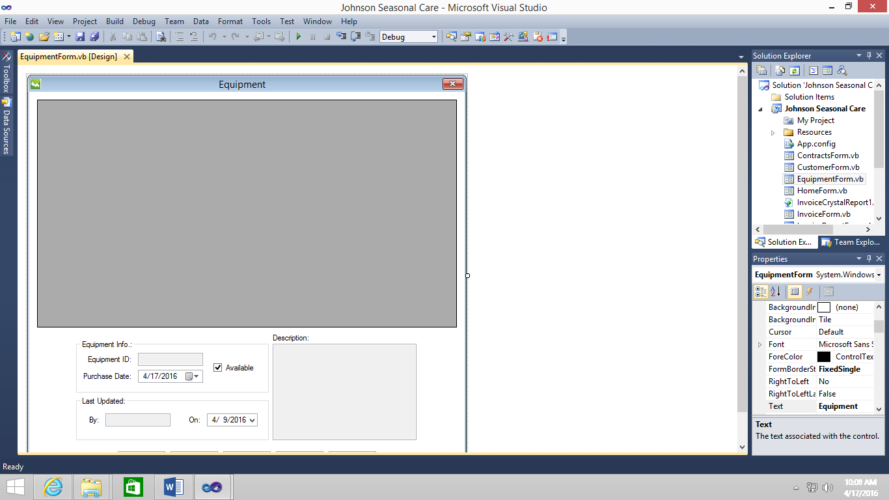

* 1. Execution View

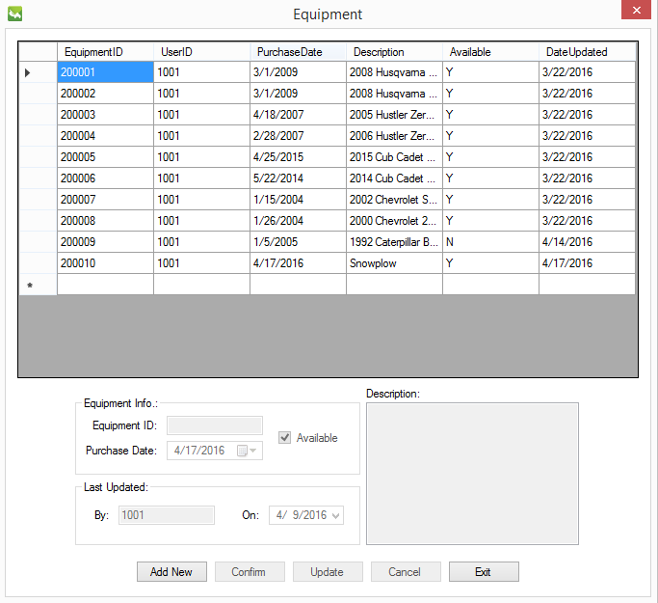

* 1. “Add New” Button is clicked.

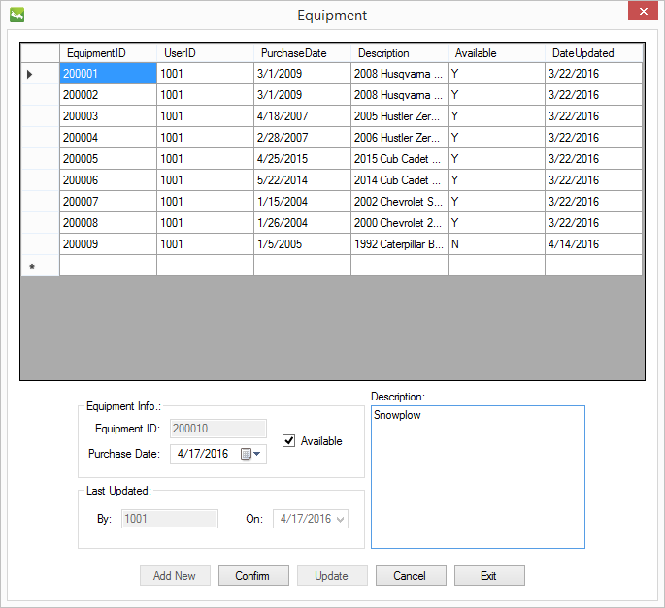

* 1. “Confirm” Button is clicked

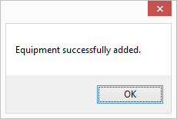

* 1. New “Snow Plow Equipment” is added.

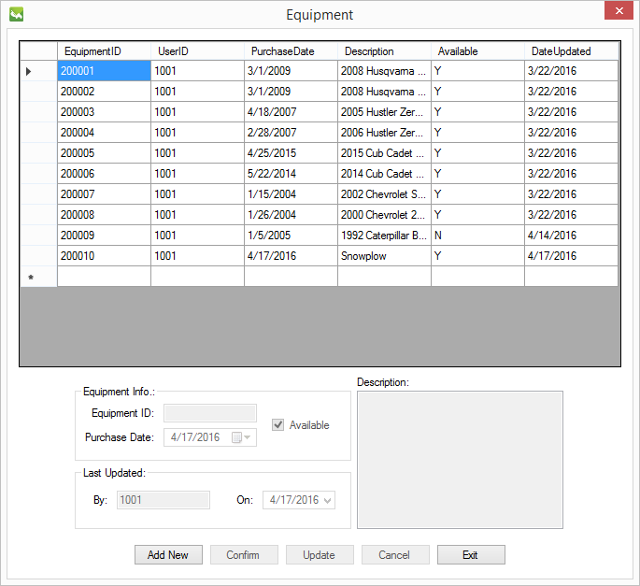

* 1. “Update” Button is clicked.

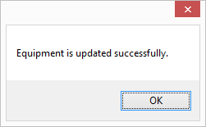

* 1. “Exit” Button is clicked.

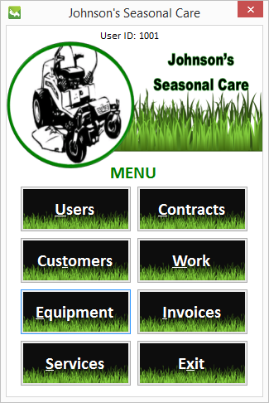

* **Services** 
  1. Service Design View

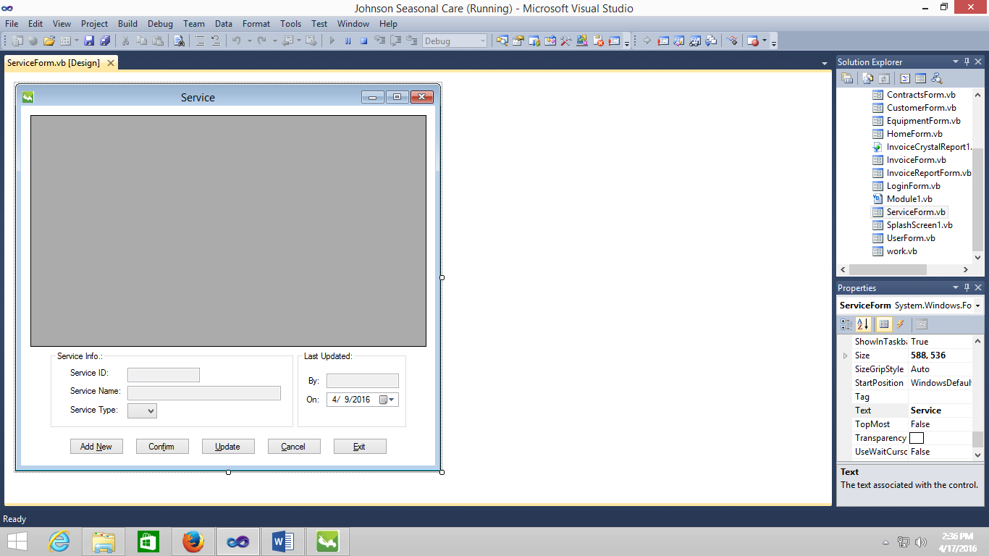

* 1. Execution View

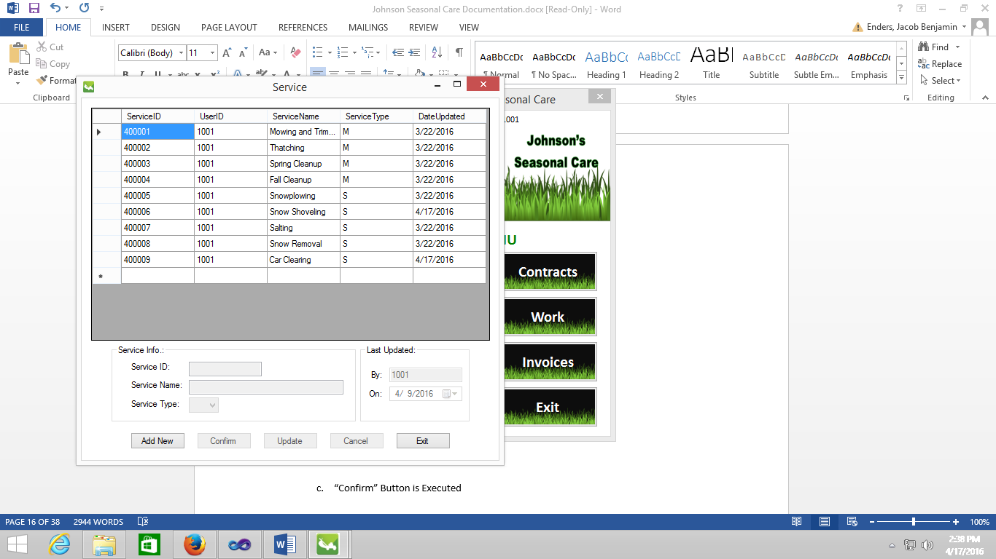

* 1. “Add New” Button is clicked.

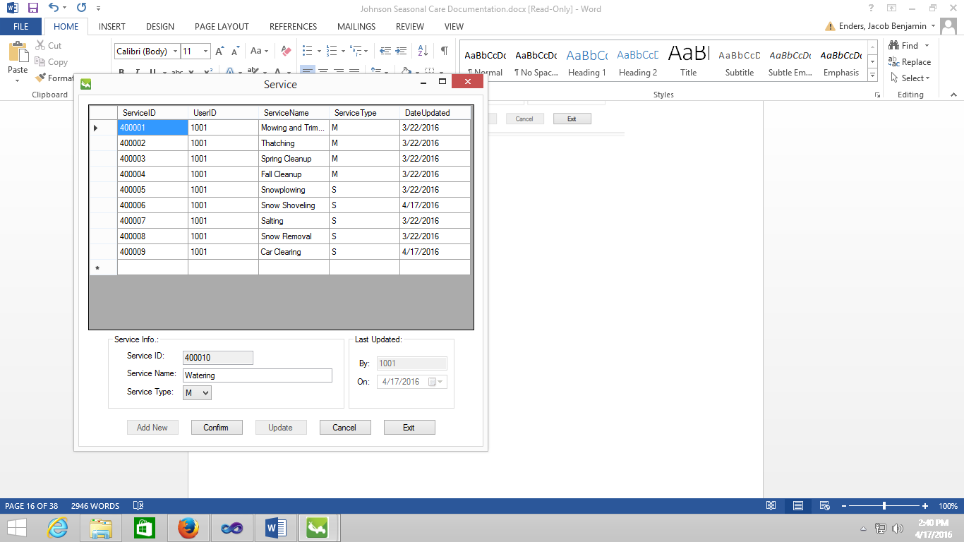

* 1. “Confirm” Button is clicked.

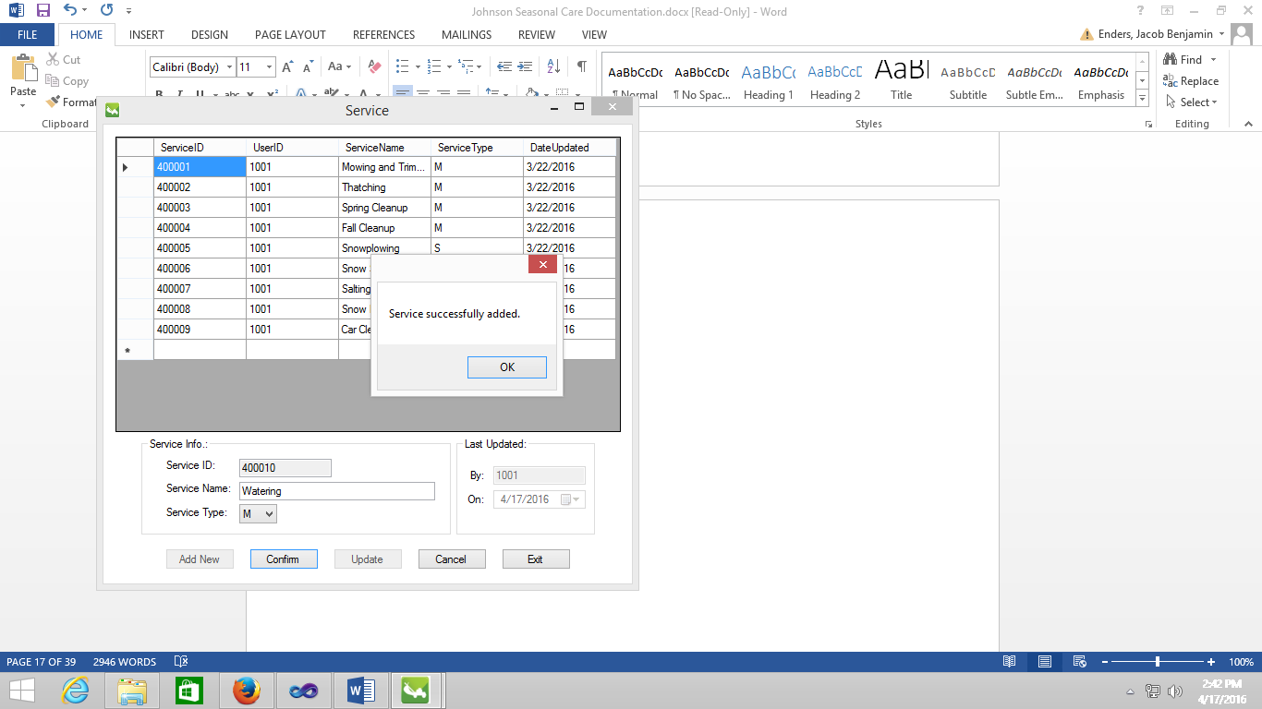

* 1. Updated data is entered.

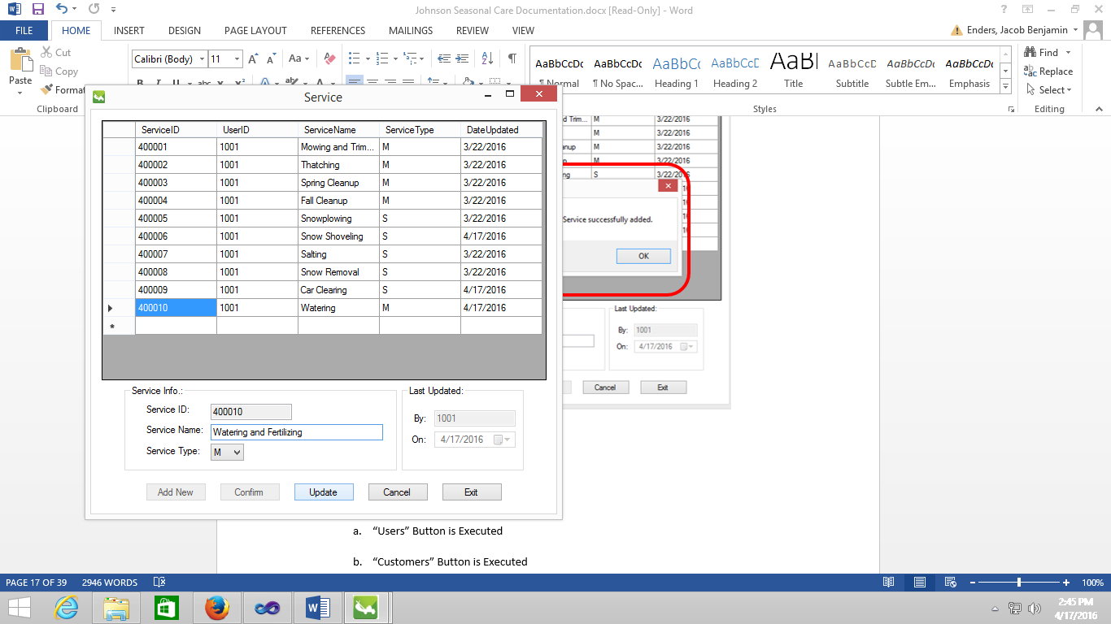

* 1. “Update” Button is clicked.

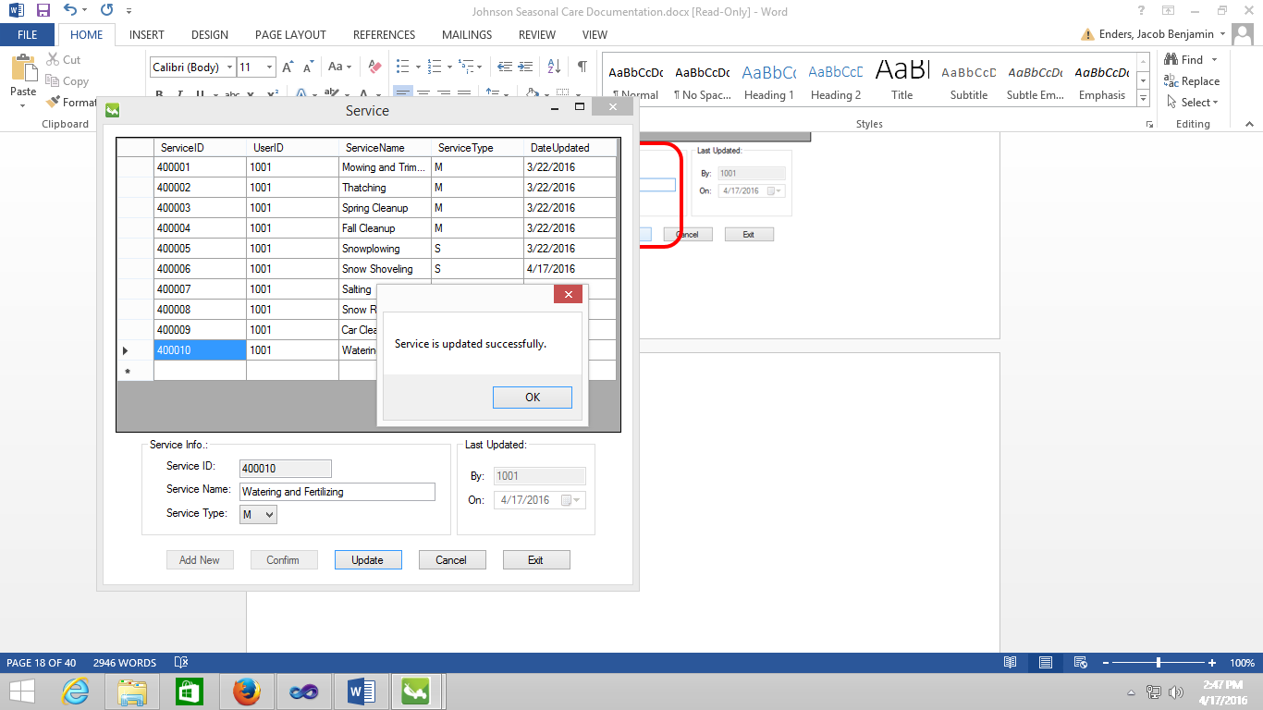

* 1. “Exit” Button is clicked.

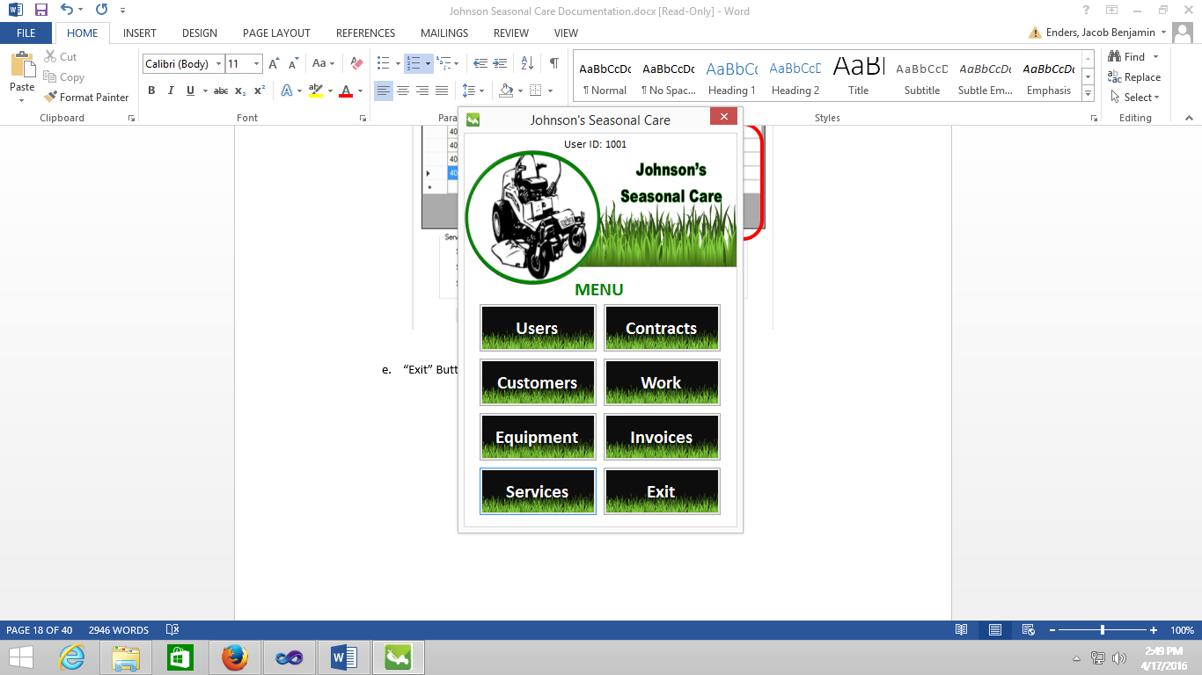

* **Contracts** 
  1. Contracts Design View

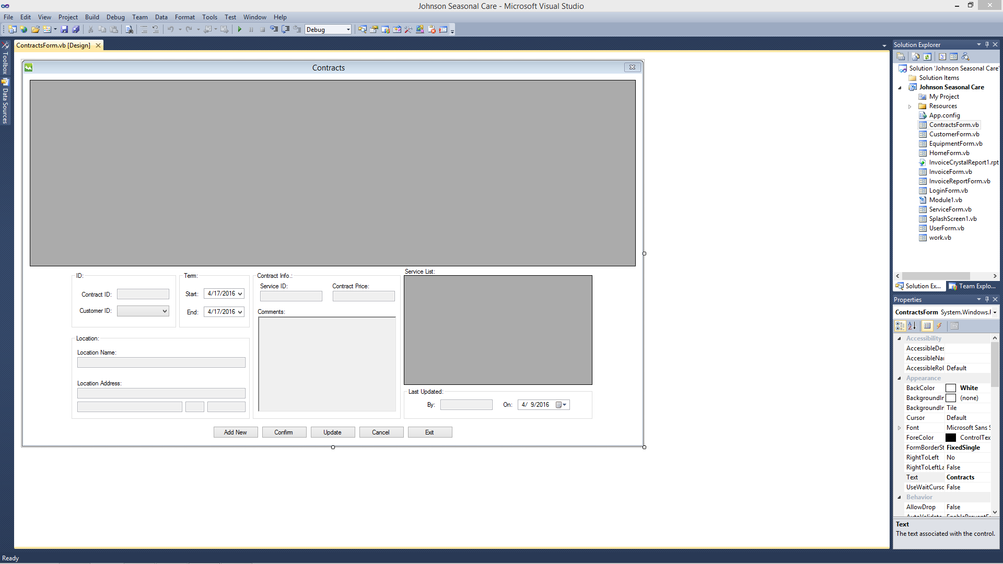

* 1. Execution View

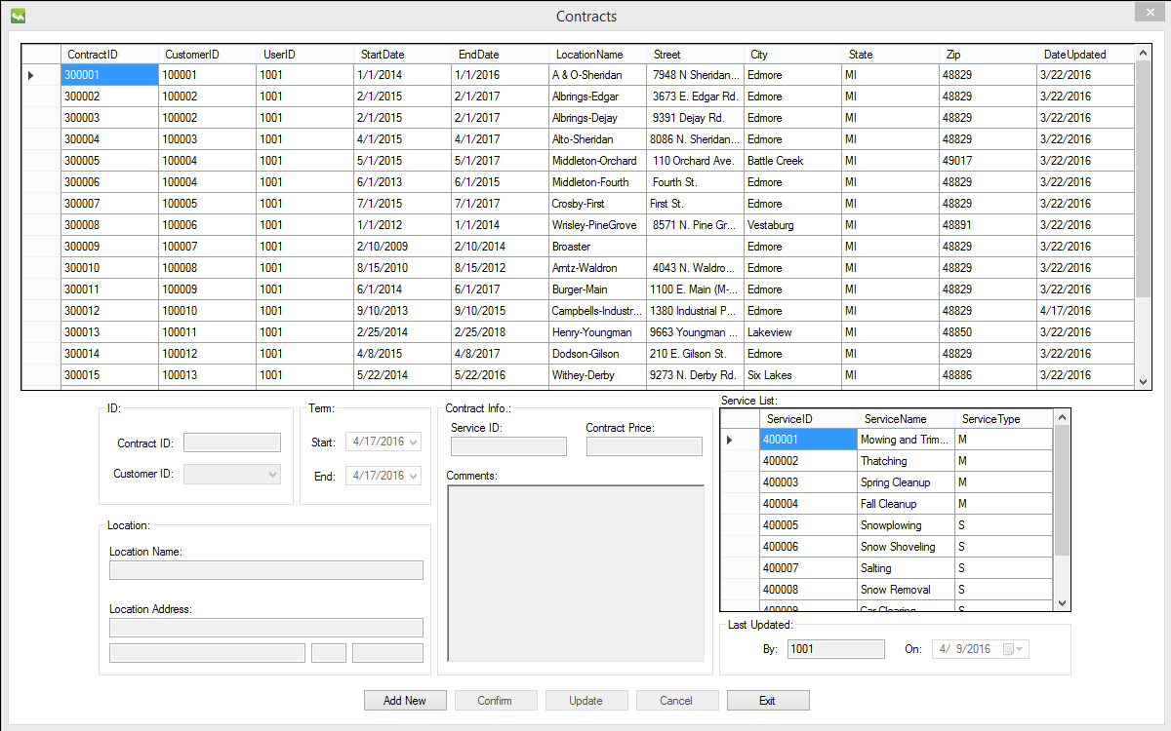

* 1. “Add New” Button is clicked.

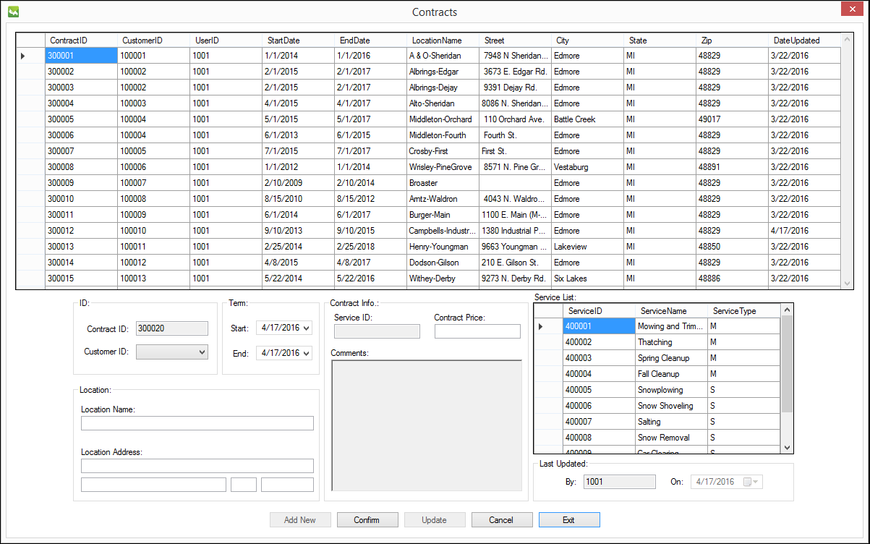

* 1. “Customer ID” is selected, “Term” is set, “Location Name” is entered, “Location Address” is entered, service is selected from “Service” data grid view, “Contract Price” is entered, “Comments” are entered, and “Confirm” button is clicked.

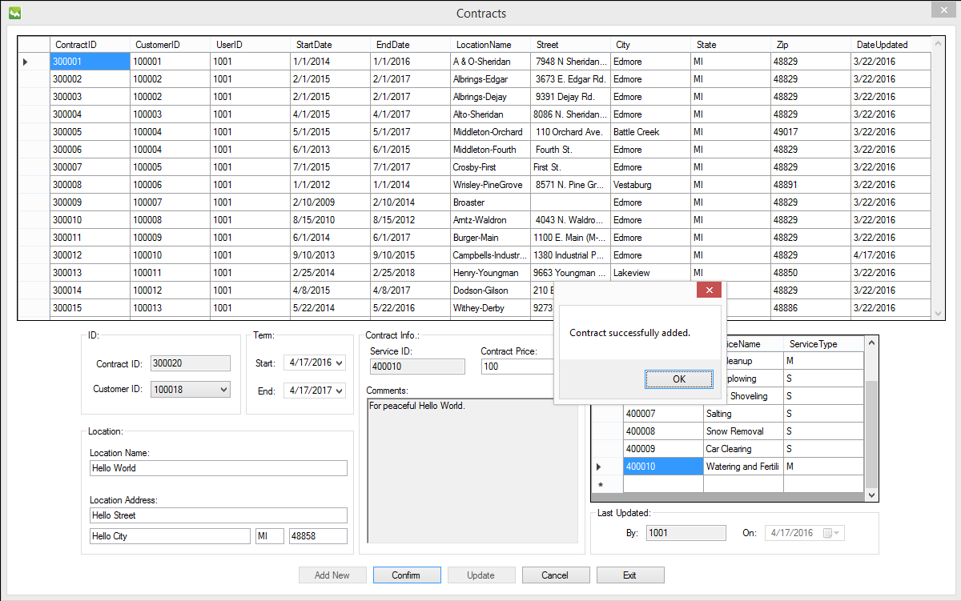

* 1. “Contract ID” 300020 is selected from the “Contract” data grid view.

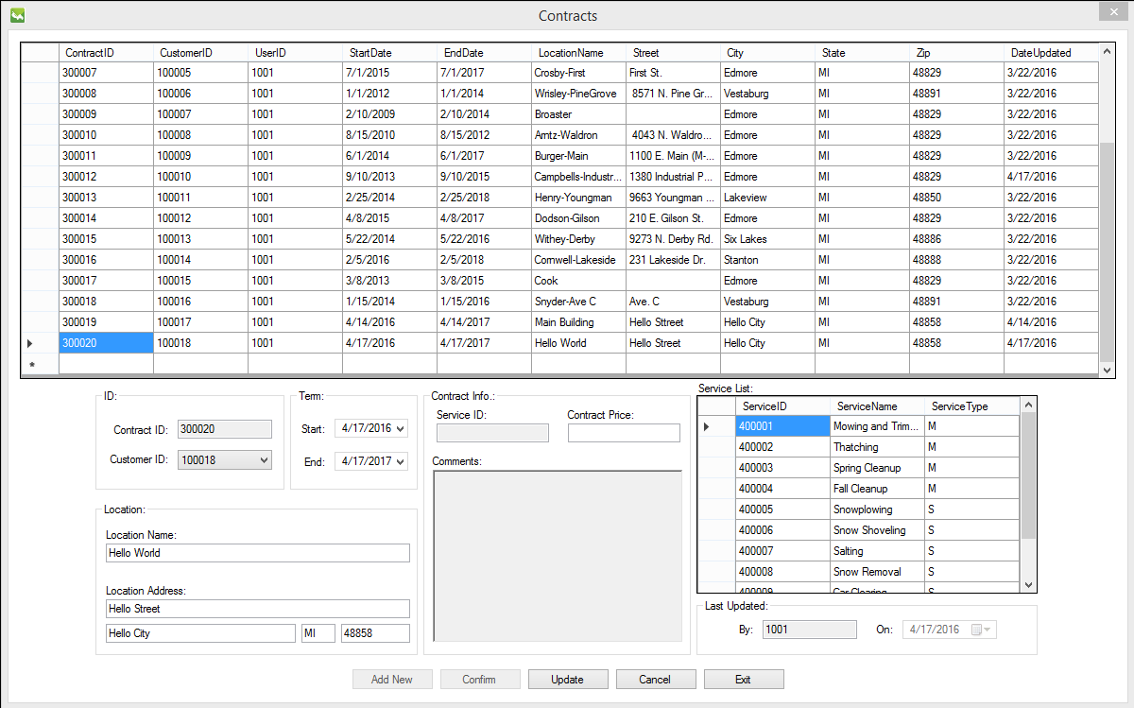

* 1. Another service is selected from “Service List” data grid view, new “Contract Price” is entered, and “Update” button is clicked.

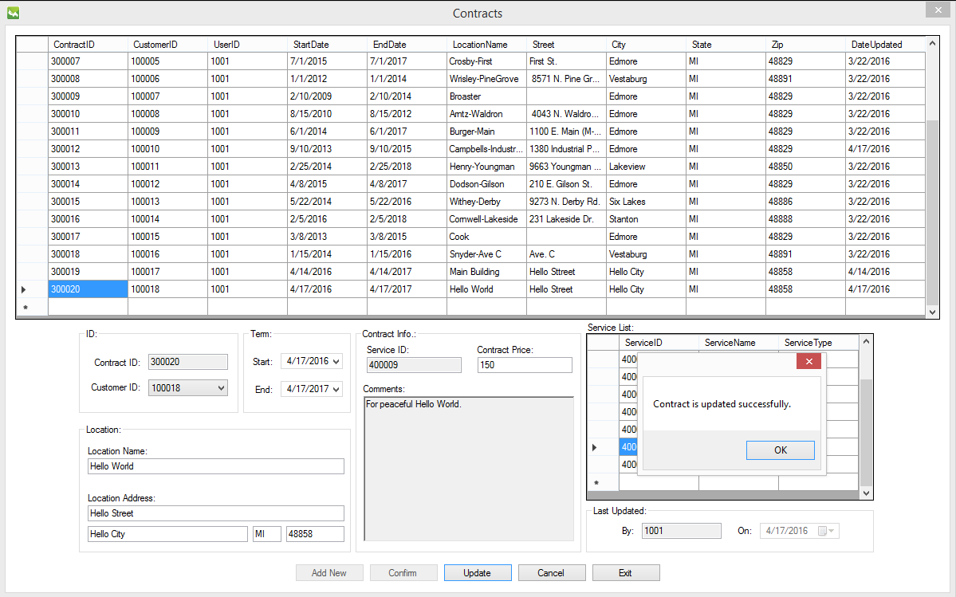

* 1. “Exit” button is clicked.

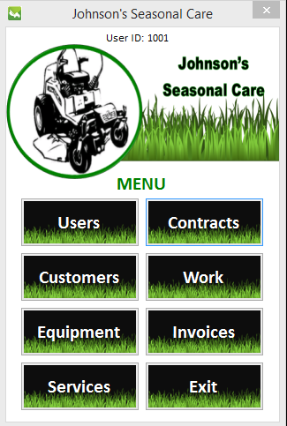

* **Work** 
  1. Work Design View

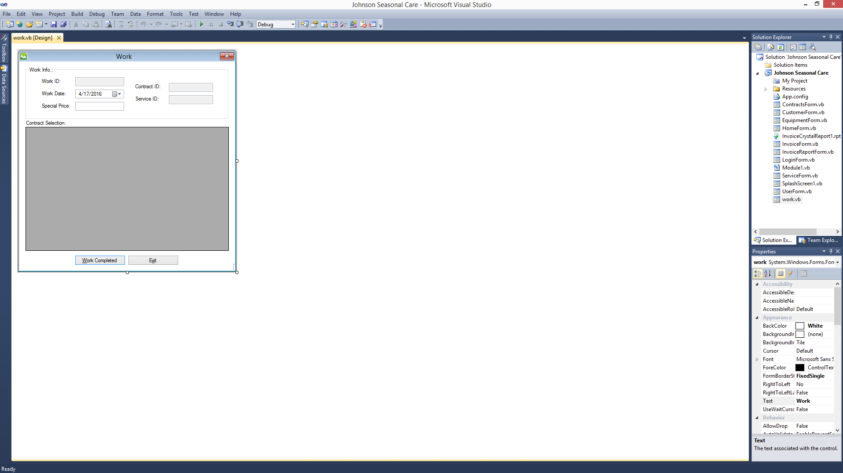

* 1. Execution View

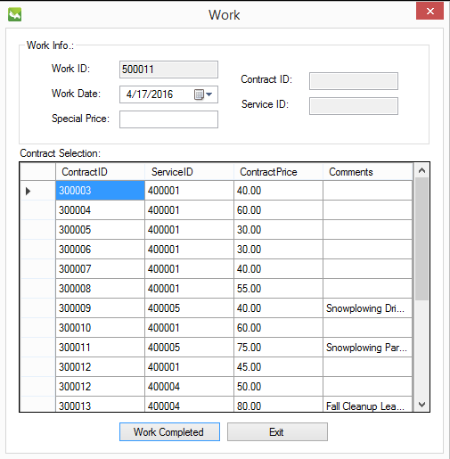

* 1. One “Contract” is selected from “Contract Selection” data grid view.

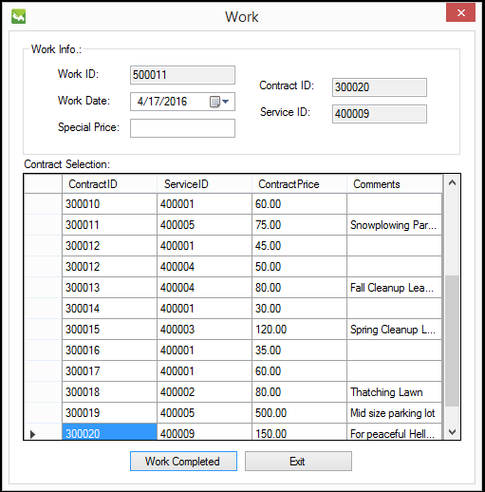

* 1. “Special Price” is entered and “Work Completed” button is clicked.

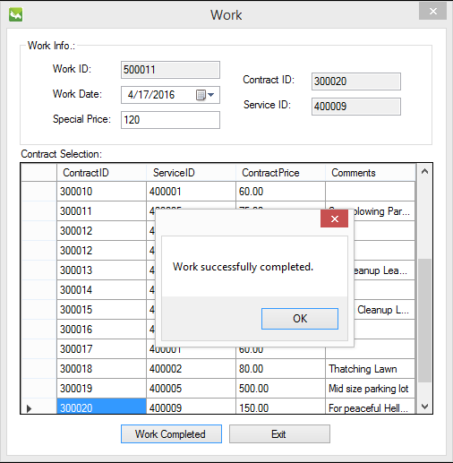

* 1. “Exit” button is clicked.



* **Invoices** 
  1. Invoice Design View

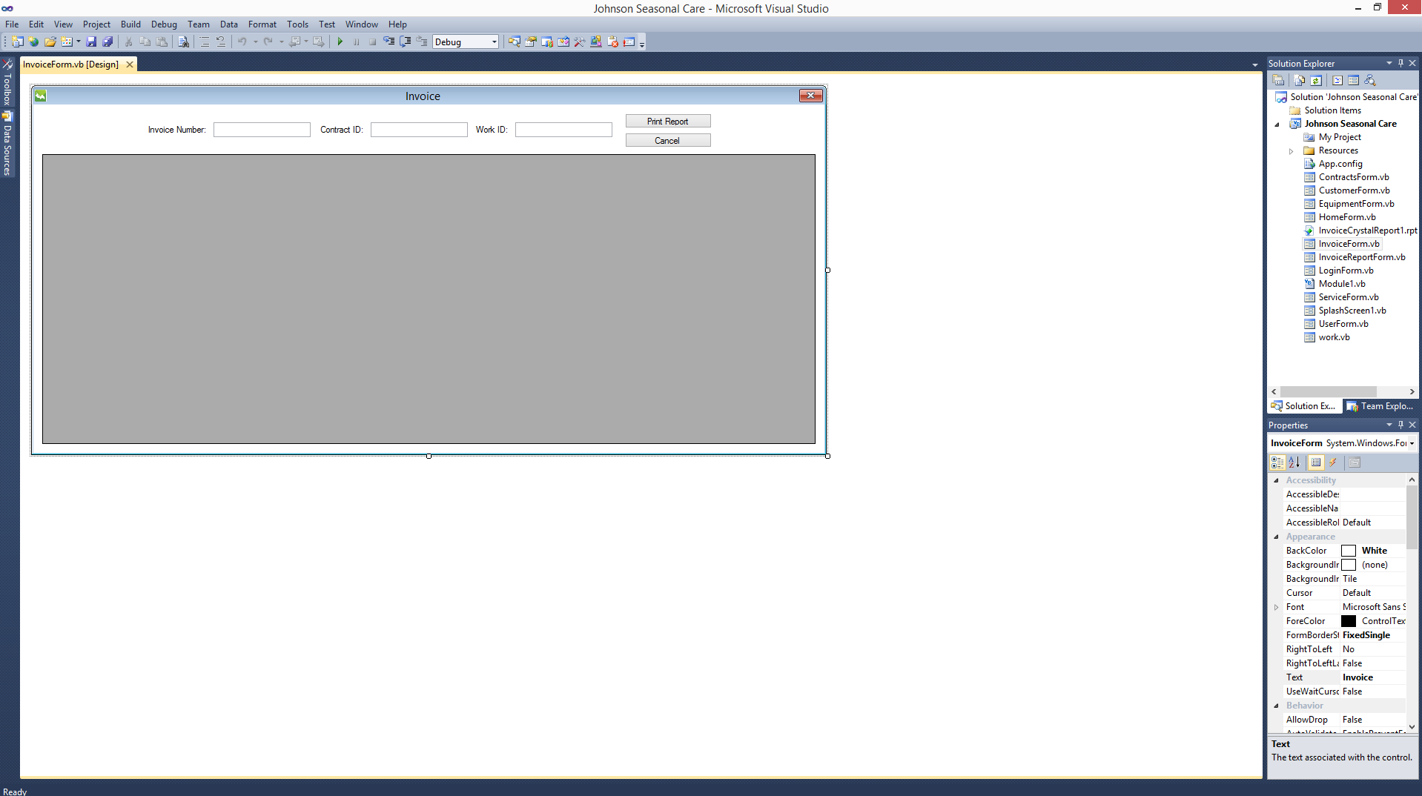

* 1. Invoice Report Design View

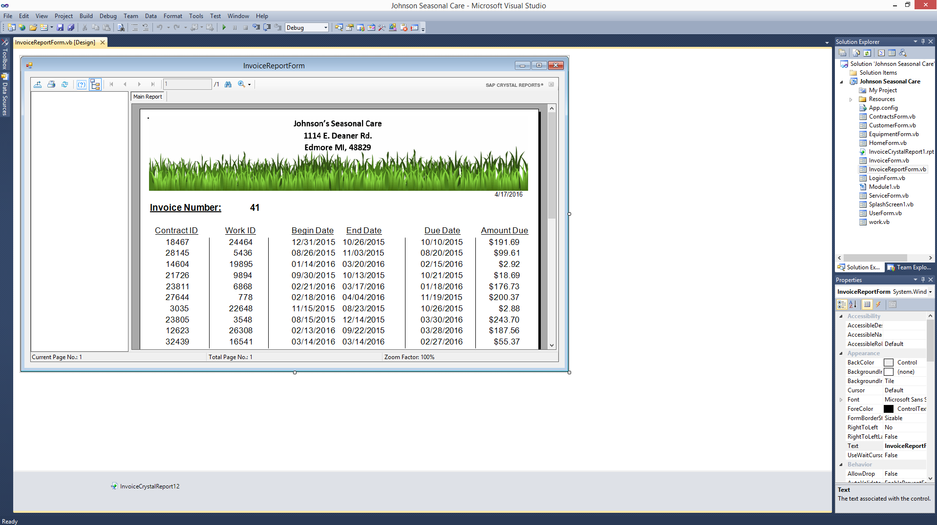

* 1. Invoice Crystal Report Design View

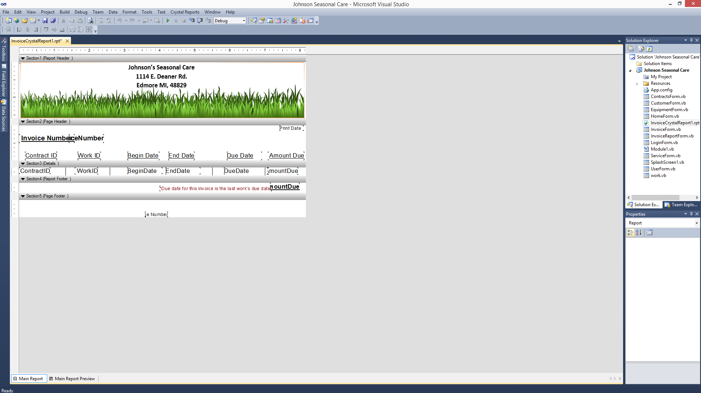

* 1. Execution View

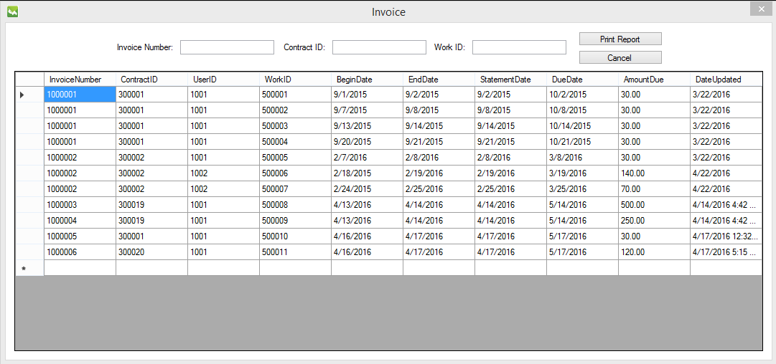

* 1. An “Invoice” is selected from the data grid view.

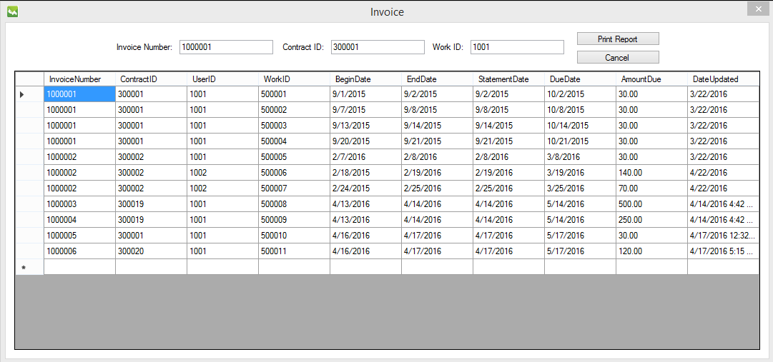

* 1. “Print Report” button is clicked.

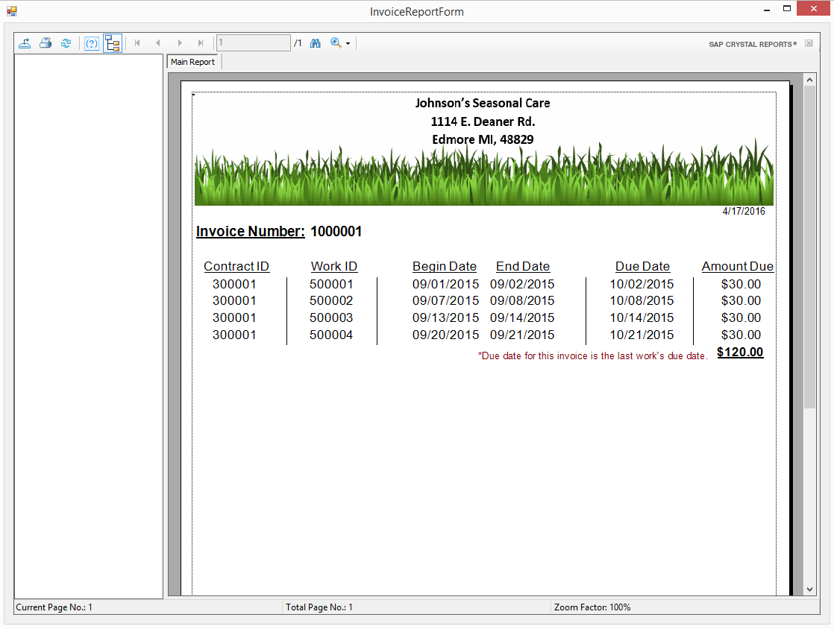

* 1. “Cancel” button is clicked.



**Codes**

Module 1:

Imports System.Data.Odbc

Imports System.Data

Imports System.Data.SqlClient

Public Class DBAccess

Private ConnectionString As String = "Driver={MySQL ODBC 5.3 ANSI Driver};SERVER=141.209.241.47;DATABASE=bis425c2g2;USER=bis425c2g2;PASSWORD=firstpass"

Private DBConnection As New OdbcConnection(ConnectionString)

Public DBReader As OdbcDataReader

Public DBCommand As New OdbcCommand

'DB Data. Make them public. Access needed from presentation tier.

Public DBDataAdapter As OdbcDataAdapter

Public DBDataTable As DataTable

'query parameters

Public Params As New List(Of OdbcParameter)

'query statistics

Public RecordCount As Integer

Public Exception As String

'create general procedure to execute database queries. SQL Strings are passed to the query as argument.

Public Sub ExecuteQuery(QueryString As String)

'reset query stats

RecordCount = 0

Exception = String.Empty

Try

'open a data connection

DBConnection.Open()

'create database command

DBCommand = New OdbcCommand(QueryString, DBConnection)

'load aparameters into DBCOmmand

For Each p As OdbcParameter In Params

DBCommand.Parameters.Add(p)

Next

Params.Clear()

'execute commands and fill database

DBDataTable = New DataTable

DBDataAdapter = New OdbcDataAdapter(DBCommand)

RecordCount = DBDataAdapter.Fill(DBDataTable)

Catch ex As Exception

'Carry message into presentation tier

Exception = ex.Message

End Try

If DBConnection.State = ConnectionState.Open Then

DBConnection.Close()

End If

End Sub

'Procedure to accept parameters for queries

Public Sub AddParam(Name As String, Value As Object)

Dim NewParam As New OdbcParameter(Name, Value)

Params.Add(NewParam)

End Sub

End Class

Log in:

Public Class LoginForm

Private DB As New DBAccess

Private Sub OK_Click(ByVal sender As System.Object, ByVal e As System.EventArgs) Handles OK.Click

If UserIDTextBox.Text = String.Empty Then

MessageBox.Show("User ID should not be empty")

UserIDTextBox.Select()

Exit Sub

Else

If PasswordTextBox.Text = String.Empty Then

MessageBox.Show("Password should not be empty!")

PasswordTextBox.Select()

Exit Sub

Else

DB.AddParam("@userid", UserIDTextBox.Text)

DB.AddParam("@userpassword", PasswordTextBox.Text)

DB.ExecuteQuery("select * from user where userid = ? and userpassword = ?")

If DB.Exception <> String.Empty Then

MessageBox.Show(DB.Exception)

Exit Sub

Else

If DB.RecordCount = 0 Then

MessageBox.Show("Wrong user ID or password")

Exit Sub

Else

'Bring User ID to other screens

Dim Obj As New HomeForm

Obj.StringPass = UserIDTextBox.Text

Obj.Show()

Me.Close()

'HomeForm.Show()

End If

End If

End If

End If

End Sub

Private Sub Cancel_Click(ByVal sender As System.Object, ByVal e As System.EventArgs) Handles Cancel.Click

Me.Close()

End Sub

Private Sub LoginForm_Load(sender As System.Object, e As System.EventArgs) Handles MyBase.Load

End Sub

End Class

Home Form:

Public Class HomeForm

Public Property StringPass As String

Private Sub HomeForm_Load(sender As System.Object, e As System.EventArgs) Handles MyBase.Load

UserIDLabel.Text = StringPass

End Sub

Private Sub EquipmentButton_Click(sender As System.Object, e As System.EventArgs) Handles EquipmentButton.Click

Dim Obj As New EquipmentForm

Obj.StringPass = UserIDLabel.Text

Obj.Show()

End Sub

Private Sub ContractButton_Click(sender As System.Object, e As System.EventArgs) Handles ContractButton.Click

Dim Obj As New ContractsForm

Obj.StringPass = UserIDLabel.Text

Obj.Show()

End Sub

Private Sub UserButton_Click(sender As System.Object, e As System.EventArgs) Handles UserButton.Click

Dim Obj As New UserForm

Obj.StringPass = UserIDLabel.Text

Obj.Show()

End Sub

Private Sub CustomerButton_Click(sender As System.Object, e As System.EventArgs) Handles CustomerButton.Click

Dim Obj As New CustomerForm

Obj.StringPass = UserIDLabel.Text

Obj.Show()

End Sub

Private Sub WorkButton_Click(sender As System.Object, e As System.EventArgs) Handles WorkButton.Click

Dim Obj As New work

Obj.StringPass = UserIDLabel.Text

Obj.Show()

End Sub

Private Sub InvoiceButton_Click(sender As System.Object, e As System.EventArgs) Handles InvoiceButton.Click

InvoiceForm.Show()

End Sub

Private Sub ServiceButton_Click(sender As System.Object, e As System.EventArgs) Handles ServiceButton.Click

Dim Obj As New ServiceForm

Obj.StringPass = UserIDLabel.Text

Obj.Show()

End Sub

Private Sub ExitButton_Click(sender As System.Object, e As System.EventArgs) Handles ExitButton.Click

Me.Close()

End Sub

End Class

User:

Imports System.Data.Common

Public Class UserForm

Public Property StringPass As String

Private DB As New DBAccess

Public SQLStr As String

Public DBreader As String

Private CurrentRecord As Integer = 0

Private Function NotEmpty(text As String) As Boolean

Return Not String.IsNullOrEmpty(text)

End Function

Private Sub UserForm_Load(sender As System.Object, e As System.EventArgs) Handles MyBase.Load

UserDataGridView.ReadOnly = True

'DB.ExecuteQuery("Select (UserID, UserName, DateOfBirth, HireDate, TerminationDate, Street, City, State, Zip, DateUpdated) From User")

DB.ExecuteQuery("Select * From User")

If DB.Exception <> String.Empty Then

MessageBox.Show(DB.Exception)

Exit Sub

End If

'Fill Data grid

UserDataGridView.DataSource = DB.DBDataTable

'Write the User ID logged in

ByTextBox.Text = StringPass

End Sub

Private Sub AddButton_Click(sender As System.Object, e As System.EventArgs) Handles AddButton.Click

'Disable DataGrid Cell Click

UserDataGridView.Enabled = False

'Enable textboxes

NameTextBox.ReadOnly = False

PasswordTextBox.ReadOnly = False

BirthDateTimePicker.Enabled = True

HireDateTimePicker.Enabled = True

StreetTextBox.ReadOnly = False

CityTextBox.ReadOnly = False

StateTextBox.ReadOnly = False

ZipTextBox.ReadOnly = False

TerminationDateTimePicker.Visible = True

CurrentLabel.Visible = True

'Disable textboxes

TerminationCheckBox.Visible = False

CurrentLabel.Visible = False

TerminationDateTimePicker.Visible = False

'Enable buttons

CancelButton.Enabled = True

ConfirmButton.Enabled = True

'Disable button

AddButton.Enabled = False

'Dateupdated = Today

OnDateTimePicker.Value = Today

'-------------------------------------------------------------------

'Select MAX User ID

DB.ExecuteQuery("SELECT MAX(UserID) MaxUserID FROM user")

If DB.Exception <> String.Empty Then

MessageBox.Show(DB.Exception)

Exit Sub

End If

'MAX User ID + 1

Dim aNewUserID As Integer = DB.DBDataTable.Rows(0)("MaxUserID") + 1

'Write User ID + 1

IDTextBox.Text = aNewUserID.ToString

'-------------------------------------------------------------------

End Sub

Private Sub ConfirmButton_Click(sender As System.Object, e As System.EventArgs) Handles ConfirmButton.Click

If NameTextBox.Text = "" Then

MessageBox.Show("Please enter Name.")

ElseIf PasswordTextBox.Text = "" Then

MessageBox.Show("Please enter Password.")

Else

'Add parameters

DB.AddParam("@UserID", IDTextBox.Text)

DB.AddParam("@EmployeeName", NameTextBox.Text)

DB.AddParam("@UserPassword", PasswordTextBox.Text)

DB.AddParam("@DateOfBirth", BirthDateTimePicker.Value)

DB.AddParam("@HireDate", HireDateTimePicker.Value)

DB.AddParam("@TerminationDate", DBNull.Value)

DB.AddParam("@Street", StreetTextBox.Text)

DB.AddParam("@City", CityTextBox.Text)

DB.AddParam("@State", StateTextBox.Text)

DB.AddParam("@Zip", ZipTextBox.Text)

DB.AddParam("@DateUpdated", OnDateTimePicker.Value)

'Execute insert

DB.ExecuteQuery("INSERT INTO User(UserID, EmployeeName, UserPassword, DateOfBirth, HireDate, TerminationDate, Street, City, State, Zip, DateUpdated) VALUES (?, ?, ?, ?, ?, ?, ?, ?, ?, ?, ?)")

'report and abort errors

If DB.Exception <> String.Empty Then

MessageBox.Show(DB.Exception)

Exit Sub

End If

MessageBox.Show("User successfully added.")

'----------------------------------------------------------------------

'Refresh table

UserDataGridView.ReadOnly = True

DB.ExecuteQuery("Select * From User")

If DB.Exception <> String.Empty Then

MessageBox.Show(DB.Exception)

Exit Sub

End If

'Fill Data grid

UserDataGridView.DataSource = DB.DBDataTable

'----------------------------------------------------------------------

'Enable DataGrid Cell click

UserDataGridView.Enabled = True

'Disable textboxes

NameTextBox.ReadOnly = True

PasswordTextBox.ReadOnly = True

BirthDateTimePicker.Enabled = False

HireDateTimePicker.Enabled = False

StreetTextBox.ReadOnly = True

CityTextBox.ReadOnly = True

StateTextBox.ReadOnly = True

ZipTextBox.ReadOnly = True

TerminationDateTimePicker.Enabled = False

TerminationCheckBox.Visible = False

'Enable button

AddButton.Enabled = True

'Disable buttons

CancelButton.Enabled = False

ConfirmButton.Enabled = False

'Clear textboxes

NameTextBox.Clear()

PasswordTextBox.Clear()

BirthDateTimePicker.Value = Today

IDTextBox.Clear()

HireDateTimePicker.Value = Today

StreetTextBox.Clear()

CityTextBox.Clear()

StateTextBox.Clear()

ZipTextBox.Clear()

TerminationDateTimePicker.Value = Today

End If

End Sub

Private Sub DBDataGridView_CellClick(sender As Object, e As System.Windows.Forms.DataGridViewCellEventArgs) Handles UserDataGridView.CellClick

If e.RowIndex < 0 Or e.ColumnIndex < 0 Then

Exit Sub

End If

'Single Item to text box

IDTextBox.Text = UserDataGridView.Item(0, e.RowIndex).Value.ToString

NameTextBox.Text = UserDataGridView.Item(1, e.RowIndex).Value.ToString

PasswordTextBox.Text = UserDataGridView.Item(2, e.RowIndex).Value.ToString

BirthDateTimePicker.Value = UserDataGridView.Item(3, e.RowIndex).Value

'address

StreetTextBox.Text = UserDataGridView.Item(6, e.RowIndex).Value.ToString

CityTextBox.Text = UserDataGridView.Item(7, e.RowIndex).Value.ToString

StateTextBox.Text = UserDataGridView.Item(8, e.RowIndex).Value.ToString

ZipTextBox.Text = UserDataGridView.Item(9, e.RowIndex).Value.ToString

'DTP

HireDateTimePicker.Value = UserDataGridView.Item(4, e.RowIndex).Value

'enable/diable

NameTextBox.ReadOnly = False

PasswordTextBox.ReadOnly = False

BirthDateTimePicker.Enabled = True

HireDateTimePicker.Enabled = True

StreetTextBox.ReadOnly = False

CityTextBox.ReadOnly = False

StateTextBox.ReadOnly = False

ZipTextBox.ReadOnly = False

TerminationCheckBox.Visible = True

TerminationCheckBox.Enabled = True

'Enable buttons

CancelButton.Enabled = True

UpdateButton.Enabled = True

'Disable buttons

AddButton.Enabled = False

ConfirmButton.Enabled = False

'Dateupdated = Today

OnDateTimePicker.Value = Today

End Sub

Private Sub UpdateButton_Click(sender As System.Object, e As System.EventArgs) Handles UpdateButton.Click

If NameTextBox.Text = "" Then

MessageBox.Show("Please enter Name.")

ElseIf PasswordTextBox.Text = "" Then

MessageBox.Show("Please enter Password.")

Else

If String.IsNullOrEmpty(IDTextBox.Text) Then

Exit Sub

End If

DB.AddParam("@UserID", IDTextBox.Text)

DB.AddParam("@EmployeeName", NameTextBox.Text)

DB.AddParam("@UserPassword", PasswordTextBox.Text)

DB.AddParam("@DateOfBirth", BirthDateTimePicker.Value)

DB.AddParam("@HireDate", HireDateTimePicker.Value)

If TerminationCheckBox.Checked = False Then

DB.AddParam("@TerminationDate", DBNull.Value)

Else

DB.AddParam("@TerminationDate", TerminationDateTimePicker.Value)

End If

DB.AddParam("@Street", StreetTextBox.Text)

DB.AddParam("@City", CityTextBox.Text)

DB.AddParam("@State", StateTextBox.Text)

DB.AddParam("@Zip", ZipTextBox.Text)

DB.AddParam("@DateUpdated", OnDateTimePicker.Value)

DB.ExecuteQuery("UPDATE IGNORE User SET UserID = ?, EmployeeName = ?, UserPassword = ?, DateOfBirth = ?, HireDate = ?, TerminationDate = ?, Street = ?, City = ?, State = ?, Zip = ?, DateUpdated = ?")

'Catch error

If NotEmpty(DB.Exception) Then

MessageBox.Show(DB.Exception)

Exit Sub

Else

MessageBox.Show("User is updated successfully.")

End If

'Enable DataGrid Cell click

UserDataGridView.Enabled = True

'Disable textboxes

NameTextBox.ReadOnly = True

PasswordTextBox.ReadOnly = True

BirthDateTimePicker.Enabled = False

HireDateTimePicker.Enabled = False

StreetTextBox.ReadOnly = True

CityTextBox.ReadOnly = True

StateTextBox.ReadOnly = True

ZipTextBox.ReadOnly = True

TerminationDateTimePicker.Enabled = False

TerminationCheckBox.Visible = False

'Enable buttons

AddButton.Enabled = True

'Disable button

ConfirmButton.Enabled = False

CancelButton.Enabled = False

'----------------------------------------------------------------------

'Refresh table

UserDataGridView.ReadOnly = True

DB.ExecuteQuery("Select * From User")

If DB.Exception <> String.Empty Then

MessageBox.Show(DB.Exception)

Exit Sub

End If

'Fill Data grid

UserDataGridView.DataSource = DB.DBDataTable

'----------------------------------------------------------------------

'Clear textboxes

NameTextBox.Clear()

PasswordTextBox.Clear()

BirthDateTimePicker.Value = Today

IDTextBox.Clear()

HireDateTimePicker.Value = Today

StreetTextBox.Clear()

CityTextBox.Clear()

StateTextBox.Clear()

ZipTextBox.Clear()

TerminationDateTimePicker.Value = Today

End If

End Sub

Private Sub TerminationCheckBox_CheckedChanged(sender As System.Object, e As System.EventArgs) Handles TerminationCheckBox.CheckedChanged

If TerminationCheckBox.Checked Then

CurrentLabel.Visible = True

TerminationDateTimePicker.Visible = True

TerminationDateTimePicker.Enabled = True

Else

CurrentLabel.Visible = False

TerminationDateTimePicker.Visible = False

TerminationDateTimePicker.Enabled = False

End If

End Sub

Private Sub CancelButton_Click(sender As System.Object, e As System.EventArgs) Handles CancelButton.Click

UserDataGridView.ReadOnly = True

DB.ExecuteQuery("Select * From User")

If DB.Exception <> String.Empty Then

MessageBox.Show(DB.Exception)

Exit Sub

End If

'Fill Data grid

UserDataGridView.DataSource = DB.DBDataTable

'Enable DataGrid Cell click

UserDataGridView.Enabled = True

'Disable textboxes

NameTextBox.ReadOnly = True

PasswordTextBox.ReadOnly = True

BirthDateTimePicker.Enabled = False

HireDateTimePicker.Enabled = False

StreetTextBox.ReadOnly = True

CityTextBox.ReadOnly = True

StateTextBox.ReadOnly = True

ZipTextBox.ReadOnly = True

TerminationDateTimePicker.Enabled = False

TerminationCheckBox.Visible = False

'Enable button

AddButton.Enabled = True

'Disable buttons

CancelButton.Enabled = False

ConfirmButton.Enabled = False

'Clear textboxes

NameTextBox.Clear()

PasswordTextBox.Clear()

BirthDateTimePicker.Value = Today

IDTextBox.Clear()

HireDateTimePicker.Value = Today

StreetTextBox.Clear()

CityTextBox.Clear()

StateTextBox.Clear()

ZipTextBox.Clear()

TerminationDateTimePicker.Value = Today

End Sub

Private Sub ExitButton_Click(sender As System.Object, e As System.EventArgs) Handles ExitButton.Click

Me.Close()

End Sub

End Class

Customer:

Public Class CustomerForm

Public Property StringPass As String

Private DB As New DBAccess

Private Function NotEmpty(text As String) As Boolean

Return Not String.IsNullOrEmpty(text)

End Function

Private Sub CustomerForm_Load(sender As System.Object, e As System.EventArgs) Handles MyBase.Load

CustomerDataGridView.ReadOnly = True

DB.ExecuteQuery("Select * From Customer")

If DB.Exception <> String.Empty Then

MessageBox.Show(DB.Exception)

Exit Sub

End If

'Fill Data grid

CustomerDataGridView.DataSource = DB.DBDataTable

'Write the User ID logged in

ByTextBox.Text = StringPass

End Sub

'Search Functions

'----------------------------------------------------------------

Private Sub NameTextbox_KeyUp(sender As Object, e As System.Windows.Forms.KeyEventArgs) Handles NameTextBox.KeyUp

DB.AddParam("@CustomerName", "%" & NameTextBox.Text & "%")

DB.ExecuteQuery("SELECT * FROM Customer WHERE CustomerName LIKE ?")

If DB.Exception <> String.Empty Then

MessageBox.Show(DB.Exception)

Exit Sub

End If

'Fill data grid

CustomerDataGridView.DataSource = DB.DBDataTable

End Sub

'----------------------------------------------------------------

Private Sub AddButton_Click(sender As System.Object, e As System.EventArgs) Handles AddButton.Click

NameTextBox.Focus()

'Disable Data Grid click

CustomerDataGridView.Enabled = False

'Enable textboxes

NameTextBox.ReadOnly = False

PhoneTextBox.ReadOnly = False

TypeComboBox.Enabled = True

StreetTextBox.ReadOnly = False

CityTextBox.ReadOnly = False

StateTextBox.ReadOnly = False

StateTextBox.Text = "MI"

ZipTextBox.ReadOnly = False

'Disable button

AddButton.Enabled = False

'Enable buttons

CancelButton.Enabled = True

ConfirmButton.Enabled = True

'Dateupdated = Today

OnDateTimePicker.Value = Today

'-------------------------------------------------------------------

'Select MAX User ID

DB.ExecuteQuery("SELECT MAX(CustomerID) MaxCustomerID FROM Customer")

If DB.Exception <> String.Empty Then

MessageBox.Show(DB.Exception)

Exit Sub

End If

'MAX User ID + 1

Dim aNewCustomerID As Integer = DB.DBDataTable.Rows(0)("MaxCustomerID") + 1

'Write User ID + 1

CustomerIDTextbox.Text = aNewCustomerID.ToString

'-------------------------------------------------------------------

End Sub

Private Sub ConfirmButton_Click(sender As System.Object, e As System.EventArgs) Handles ConfirmButton.Click

If NameTextBox.Text = "" Then

MessageBox.Show("Please enter Name.")

Else

DB.AddParam("@CustomerID", CustomerIDTextbox.Text)

DB.AddParam("@UserID", ByTextBox.Text)

DB.AddParam("@CustomerName", NameTextBox.Text)

DB.AddParam("@Street", StreetTextBox.Text)

DB.AddParam("@City", CityTextBox.Text)

DB.AddParam("@State", StateTextBox.Text)

DB.AddParam("@Zip", ZipTextBox.Text)

DB.AddParam("@Phone", PhoneTextBox.Text)

DB.AddParam("@TypeRC", TypeComboBox.Text)

DB.AddParam("@DateUpdated", OnDateTimePicker.Value)

DB.ExecuteQuery("INSERT INTO Customer(CustomerID, UserID, CustomerName, Street, City, State, Zip, Phone, TypeRC, DateUpdated) VALUES (?, ?, ?, ?, ?, ?, ?, ?, ?, ?)")

If DB.Exception <> String.Empty Then

MessageBox.Show(DB.Exception)

Exit Sub

End If

MessageBox.Show("Customer successfully added.")

'--------------------------------------------------------------------

'Refresh table

CustomerDataGridView.ReadOnly = True

DB.ExecuteQuery("Select * From Customer")

If DB.Exception <> String.Empty Then

MessageBox.Show(DB.Exception)

Exit Sub

End If

'Fill Data grid

CustomerDataGridView.DataSource = DB.DBDataTable

'--------------------------------------------------------------------

'Enable Data Grid click

CustomerDataGridView.Enabled = True

'Enable/Disable textboxes

CustomerIDTextbox.ReadOnly = True

'NameTextBox.ReadOnly = True

PhoneTextBox.ReadOnly = True

StreetTextBox.ReadOnly = True

CityTextBox.ReadOnly = True

StateTextBox.ReadOnly = True

ZipTextBox.ReadOnly = True

TypeComboBox.Enabled = False

'Disable buttons

CancelButton.Enabled = False

ConfirmButton.Enabled = False

UpdateButton.Enabled = False

'Enable button

AddButton.Enabled = True

'Clears

CustomerIDTextbox.Clear()

NameTextBox.Clear()

StreetTextBox.Clear()

CityTextBox.Clear()

StateTextBox.Clear()

ZipTextBox.Clear()

PhoneTextBox.Clear()

TypeComboBox.SelectedIndex = -1

End If

End Sub

Private Sub DBDataGridView_CellClick(sender As Object, e As System.Windows.Forms.DataGridViewCellEventArgs) Handles CustomerDataGridView.CellClick

If e.RowIndex < 0 Or e.ColumnIndex < 0 Then

Exit Sub

End If

'Single Item to text box

CustomerIDTextbox.Text = CustomerDataGridView.Item(0, e.RowIndex).Value.ToString

NameTextBox.Text = CustomerDataGridView.Item(2, e.RowIndex).Value.ToString

PhoneTextBox.Text = CustomerDataGridView.Item(7, e.RowIndex).Value.ToString

'address

StreetTextBox.Text = CustomerDataGridView.Item(3, e.RowIndex).Value.ToString

CityTextBox.Text = CustomerDataGridView.Item(4, e.RowIndex).Value.ToString

StateTextBox.Text = CustomerDataGridView.Item(5, e.RowIndex).Value.ToString

ZipTextBox.Text = CustomerDataGridView.Item(6, e.RowIndex).Value.ToString

TypeComboBox.Text = CustomerDataGridView.Item(8, e.RowIndex).Value.ToString

'DTP

OnDateTimePicker.Value = CustomerDataGridView.Item(9, e.RowIndex).Value

'Buttons

AddButton.Enabled = False

ConfirmButton.Enabled = False

UpdateButton.Enabled = True

CancelButton.Enabled = True

'Textboxes

CustomerIDTextbox.ReadOnly = True

NameTextBox.ReadOnly = False

StreetTextBox.ReadOnly = False

CityTextBox.ReadOnly = False

StateTextBox.ReadOnly = False

ZipTextBox.ReadOnly = False

PhoneTextBox.ReadOnly = False

TypeComboBox.Enabled = True

'Dateupdated = Today

OnDateTimePicker.Value = Today

End Sub

Private Sub UpdateButton_Click(sender As System.Object, e As System.EventArgs) Handles UpdateButton.Click

If NameTextBox.Text = "" Then

MessageBox.Show("Please enter Name.")

Else

If String.IsNullOrEmpty(CustomerIDTextbox.Text) Then

Exit Sub

End If

DB.AddParam("@CustomerID", CustomerIDTextbox.Text)

DB.AddParam("@UserID", ByTextBox.Text)

DB.AddParam("@CustomerName", NameTextBox.Text)

DB.AddParam("@Street", StreetTextBox.Text)

DB.AddParam("@City", CityTextBox.Text)

DB.AddParam("@State", StateTextBox.Text)

DB.AddParam("@Zip", ZipTextBox.Text)

DB.AddParam("@Phone", PhoneTextBox.Text)

DB.AddParam("@TypeRC", TypeComboBox.Text)

DB.AddParam("@DateUpdated", OnDateTimePicker.Value)

DB.ExecuteQuery("UPDATE IGNORE Customer SET CustomerID = ?, UserID = ?, CustomerName = ?, Street = ?, City = ?, State = ?, Zip = ?, Phone = ?, TypeRC = ?, DateUpdated = ?")

If NotEmpty(DB.Exception) Then

MessageBox.Show(DB.Exception)

Exit Sub

Else

MessageBox.Show("Customer is updated successfully.")

End If

'Enable Data Grid click

CustomerDataGridView.Enabled = True

'Disable textboxes

CustomerIDTextbox.ReadOnly = True

ByTextBox.ReadOnly = True

NameTextBox.ReadOnly = True

StreetTextBox.ReadOnly = True

CityTextBox.ReadOnly = True

StateTextBox.ReadOnly = True

ZipTextBox.ReadOnly = True

PhoneTextBox.ReadOnly = True

TypeComboBox.Enabled = False

OnDateTimePicker.Enabled = False

'Enable button

CancelButton.Enabled = True

AddButton.Enabled = True

'Disable buttons

UpdateButton.Enabled = False

ConfirmButton.Enabled = False

'------------------------------------------------------------

'Refresh table

CustomerDataGridView.ReadOnly = True

DB.ExecuteQuery("Select * From Customer")

If DB.Exception <> String.Empty Then

MessageBox.Show(DB.Exception)

Exit Sub

End If

'Fill Data grid

CustomerDataGridView.DataSource = DB.DBDataTable

'------------------------------------------------------------

'Clears

CustomerIDTextbox.Clear()

NameTextBox.Clear()

StreetTextBox.Clear()

CityTextBox.Clear()

StateTextBox.Clear()

ZipTextBox.Clear()

PhoneTextBox.Clear()

TypeComboBox.SelectedIndex = -1

End If

End Sub

Private Sub CancelButton_Click(sender As System.Object, e As System.EventArgs) Handles CancelButton.Click

CustomerDataGridView.ReadOnly = True

DB.ExecuteQuery("Select * From Customer")

If DB.Exception <> String.Empty Then

MessageBox.Show(DB.Exception)

Exit Sub

End If

'Fill Data grid

CustomerDataGridView.DataSource = DB.DBDataTable

'Enable Data Grid click

CustomerDataGridView.Enabled = True

'enable/diable

CustomerIDTextbox.ReadOnly = True

'NameTextBox.ReadOnly = True

PhoneTextBox.ReadOnly = True

StreetTextBox.ReadOnly = True

CityTextBox.ReadOnly = True

StateTextBox.ReadOnly = True

ZipTextBox.ReadOnly = True

TypeComboBox.Enabled = False

'Disable buttons

CancelButton.Enabled = False

ConfirmButton.Enabled = False

UpdateButton.Enabled = False

'Enable button

AddButton.Enabled = True

'Clears

CustomerIDTextbox.Clear()

NameTextBox.Clear()

StreetTextBox.Clear()

CityTextBox.Clear()

StateTextBox.Clear()

ZipTextBox.Clear()

PhoneTextBox.Clear()

TypeComboBox.SelectedIndex = -1

End Sub

Private Sub ExitButton_Click(sender As System.Object, e As System.EventArgs) Handles ExitButton.Click

Me.Close()

End Sub

End Class

Equipment:

Public Class EquipmentForm

Public Property StringPass As String

Private DB As New DBAccess

Public SQLStr As String

Dim AvailableString As String

Private Function NotEmpty(text As String) As Boolean

Return Not String.IsNullOrEmpty(text)

End Function

Private Sub EquipmentForm_Load(sender As System.Object, e As System.EventArgs) Handles MyBase.Load

EquipmentDataGridView.ReadOnly = True

DB.ExecuteQuery("Select * From Equipment")

If DB.Exception <> String.Empty Then

MessageBox.Show(DB.Exception)

Exit Sub

End If

'Fill Data grid

EquipmentDataGridView.DataSource = DB.DBDataTable

'Write the User ID logged in

ByTextBox.Text = StringPass

End Sub

Private Sub AddButton_Click(sender As System.Object, e As System.EventArgs) Handles AddButton.Click

DescriptionTextBox.Focus()

'Disable Data Grid click

EquipmentDataGridView.Enabled = False

'Enable textboxes

IDTextBox.ReadOnly = False

PurchaseDateTimePicker.Enabled = True

DescriptionTextBox.ReadOnly = False

AvailableCheckBox.Enabled = True

'Enable buttons

ConfirmButton.Enabled = True

CancelButton.Enabled = True

ExitButton.Enabled = True

'Disable buttons

AddButton.Enabled = False

UpdateButton.Enabled = False

'Dateupdated = Today

OnDateTimePicker.Value = Today

'-------------------------------------------------------------------

'Select MAX User ID

DB.ExecuteQuery("SELECT MAX(EquipmentID) MaxEquipmentID FROM Equipment")

If DB.Exception <> String.Empty Then

MessageBox.Show(DB.Exception)

Exit Sub

End If

'MAX User ID + 1

Dim aNewEquipmentID As Integer = DB.DBDataTable.Rows(0)("MaxEquipmentID") + 1

'Write User ID + 1

IDTextBox.Text = aNewEquipmentID.ToString

'-------------------------------------------------------------------

End Sub

Private Sub ConfirmButton_Click(sender As System.Object, e As System.EventArgs) Handles ConfirmButton.Click

'Check AvailableCheckBox

If AvailableCheckBox.Checked = True Then

AvailableString = "Y"

ElseIf AvailableCheckBox.Checked = False Then

AvailableString = "N"

End If

'Add parameters

DB.AddParam("@EquipmentID", IDTextBox.Text)

DB.AddParam("@UserID", ByTextBox.Text)

DB.AddParam("@PurchaseDate", PurchaseDateTimePicker.Value)

DB.AddParam("@Description", DescriptionTextBox.Text)

DB.AddParam("@Available", AvailableString)

DB.AddParam("@DateUpdated", OnDateTimePicker.Value)

'Execute insert

DB.ExecuteQuery("INSERT INTO Equipment(EquipmentID, UserID, PurchaseDate, Description, Available, DateUpdated) VALUES (?, ?, ?, ?, ?, ?)")

'Catch exception

If DB.Exception <> String.Empty Then

MessageBox.Show(DB.Exception)

Exit Sub

End If

MessageBox.Show("Equipment successfully added.")

'------------------------------------------------------------

'Refresh table

EquipmentDataGridView.ReadOnly = True

DB.ExecuteQuery("Select * From Equipment")

If DB.Exception <> String.Empty Then

MessageBox.Show(DB.Exception)

Exit Sub

End If

'Fill Data grid

EquipmentDataGridView.DataSource = DB.DBDataTable

'------------------------------------------------------------

'Enable Data Grid click

EquipmentDataGridView.Enabled = True

'Disable textboxes

IDTextBox.ReadOnly = True

ByTextBox.ReadOnly = True

PurchaseDateTimePicker.Enabled = False

DescriptionTextBox.ReadOnly = True

AvailableCheckBox.Enabled = False

OnDateTimePicker.Enabled = False

'Enable button

AddButton.Enabled = True

ExitButton.Enabled = True

'Disable buttons

ConfirmButton.Enabled = False

UpdateButton.Enabled = False

CancelButton.Enabled = False

'Clear textboxes

IDTextBox.Clear()

PurchaseDateTimePicker.Value = Today

DescriptionTextBox.Clear()

End Sub

Private Sub DBDataGridView_CellClick(sender As Object, e As System.Windows.Forms.DataGridViewCellEventArgs) Handles EquipmentDataGridView.CellClick

If e.RowIndex < 0 Or e.ColumnIndex < 0 Then

Exit Sub

End If

'Single Item to text box

IDTextBox.Text = EquipmentDataGridView.Item(0, e.RowIndex).Value.ToString

ByTextBox.Text = EquipmentDataGridView.Item(1, e.RowIndex).Value.ToString

PurchaseDateTimePicker.Value = EquipmentDataGridView.Item(2, e.RowIndex).Value

DescriptionTextBox.Text = EquipmentDataGridView.Item(3, e.RowIndex).Value.ToString

'AvailableTextBox.Text = EquipmentDataGridView.Item(4, e.RowIndex).Value.ToString

OnDateTimePicker.Value = EquipmentDataGridView.Item(5, e.RowIndex).Value

'Enable Textboxes

IDTextBox.ReadOnly = False

ByTextBox.ReadOnly = False

PurchaseDateTimePicker.Enabled = True

DescriptionTextBox.ReadOnly = False

AvailableCheckBox.Enabled = True

OnDateTimePicker.Value = Today

'Enable buttons

UpdateButton.Enabled = True

CancelButton.Enabled = True

ExitButton.Enabled = True

'Disable buttons

AddButton.Enabled = False

ConfirmButton.Enabled = False

End Sub

Private Sub UpdateButton_Click(sender As System.Object, e As System.EventArgs) Handles UpdateButton.Click

If String.IsNullOrEmpty(IDTextBox.Text) Then

Exit Sub

End If

'Check AvailableCheckBox

If AvailableCheckBox.Checked = True Then

AvailableString = "Y"

ElseIf AvailableCheckBox.Checked = False Then

AvailableString = "N"

End If

'Add parameters

DB.AddParam("@EquipmentID", IDTextBox.Text)

DB.AddParam("@UserID", ByTextBox.Text)

DB.AddParam("@PurchaseDate", PurchaseDateTimePicker.Value)

DB.AddParam("@Description", DescriptionTextBox.Text)

DB.AddParam("@Available", AvailableString)

DB.AddParam("@DateUpdated", OnDateTimePicker.Value)

DB.ExecuteQuery("UPDATE IGNORE Equipment SET EquipmentID = ?, UserID = ?, PurchaseDate = ?, Description = ?, Available = ?, DateUpdated = ?")

If NotEmpty(DB.Exception) Then

MessageBox.Show(DB.Exception)

Exit Sub

Else

MessageBox.Show("Equipment is updated successfully.")

End If

'Enable Data Grid click

EquipmentDataGridView.Enabled = True

'Disable textboxes

IDTextBox.ReadOnly = True

ByTextBox.ReadOnly = True

PurchaseDateTimePicker.Enabled = False

DescriptionTextBox.ReadOnly = True

AvailableCheckBox.Enabled = False

OnDateTimePicker.Enabled = False

'Enable buttons

CancelButton.Enabled = True

AddButton.Enabled = True

'Disable button

ConfirmButton.Enabled = False

UpdateButton.Enabled = False

CancelButton.Enabled = False

'------------------------------------------------------------

'Refresh table

EquipmentDataGridView.ReadOnly = True

DB.ExecuteQuery("Select * From Equipment")

If DB.Exception <> String.Empty Then

MessageBox.Show(DB.Exception)

Exit Sub

End If

'Fill Data grid

EquipmentDataGridView.DataSource = DB.DBDataTable

'------------------------------------------------------------

'Clear textboxes

IDTextBox.Clear()

PurchaseDateTimePicker.Value = Today

DescriptionTextBox.Clear()

End Sub

Private Sub CancelButton_Click(sender As System.Object, e As System.EventArgs) Handles CancelButton.Click

EquipmentDataGridView.ReadOnly = True

DB.ExecuteQuery("Select * From Equipment")

If DB.Exception <> String.Empty Then

MessageBox.Show(DB.Exception)

Exit Sub

End If

'Fill Data grid

EquipmentDataGridView.DataSource = DB.DBDataTable

'Enable Data Grid click

EquipmentDataGridView.Enabled = True

'Disable textboxes

IDTextBox.ReadOnly = True

ByTextBox.ReadOnly = True

PurchaseDateTimePicker.Enabled = False

DescriptionTextBox.ReadOnly = True

AvailableCheckBox.Enabled = False

OnDateTimePicker.Enabled = False

'Clear textboxes

IDTextBox.Clear()

PurchaseDateTimePicker.Value = Today

DescriptionTextBox.Clear()

'Enable button

AddButton.Enabled = True

ExitButton.Enabled = True

'Disable buttons

ConfirmButton.Enabled = False

UpdateButton.Enabled = False

CancelButton.Enabled = False

End Sub

Private Sub ExitButton_Click(sender As System.Object, e As System.EventArgs) Handles ExitButton.Click

Me.Close()

End Sub

End Class

Services:

Public Class ServiceForm

Public Property StringPass As String

Private DB As New DBAccess

Public SQLStr As String

Public DBreader As String

Private CurrentRecord As Integer = 0

Private Function NotEmpty(text As String) As Boolean

Return Not String.IsNullOrEmpty(text)

End Function

Private Sub ServiceForm_Load(sender As System.Object, e As System.EventArgs) Handles MyBase.Load

DB.ExecuteQuery("Select * From Service")

If DB.Exception <> String.Empty Then

MessageBox.Show(DB.Exception)

Exit Sub

End If

'Fill Data grid

ServiceDataGridView.DataSource = DB.DBDataTable

'Write the User ID logged in

ByTextBox.Text = StringPass

End Sub

Private Sub AddButton_Click(sender As System.Object, e As System.EventArgs) Handles AddButton.Click

NameTextBox.Focus()

'Disable Data Grid click

ServiceDataGridView.Enabled = False

'Enable textboxes

NameTextBox.ReadOnly = False

TypeComboBox.Enabled = True

'Enable buttons

CancelButton.Enabled = True

ConfirmButton.Enabled = True

'Disable buttons

AddButton.Enabled = False

UpdateButton.Enabled = False

'Dateupdated = Today

OnDateTimePicker.Value = Today

'-------------------------------------------------------------------

'Select MAX User ID

DB.ExecuteQuery("SELECT MAX(ServiceID) MaxServiceID FROM Service")

If DB.Exception <> String.Empty Then

MessageBox.Show(DB.Exception)

Exit Sub

End If

'MAX User ID + 1

Dim aNewServiceID As Integer = DB.DBDataTable.Rows(0)("MaxServiceID") + 1

'Write User ID + 1

IDTextBox.Text = aNewServiceID.ToString

'-------------------------------------------------------------------

'Refresh table

ServiceDataGridView.ReadOnly = True

DB.ExecuteQuery("Select * From Service")

If DB.Exception <> String.Empty Then

MessageBox.Show(DB.Exception)

Exit Sub

End If

'Fill Data grid

ServiceDataGridView.DataSource = DB.DBDataTable

End Sub

Private Sub ConfirmButton_Click(sender As System.Object, e As System.EventArgs) Handles ConfirmButton.Click

If NameTextBox.Text = "" Then

MessageBox.Show("Please enter Service Name.")

Else

'Add parameters

DB.AddParam("@ServiceID", IDTextBox.Text)

DB.AddParam("@UserID", ByTextBox.Text)

DB.AddParam("@ServiceName", NameTextBox.Text)

DB.AddParam("@ServiceType", TypeComboBox.Text)

DB.AddParam("@DateUpdated", OnDateTimePicker.Value)

'Execute insert

DB.ExecuteQuery("INSERT INTO Service(ServiceID, UserID, ServiceName, ServiceType, DateUpdated) VALUES (?, ?, ?, ?, ?)")

'Catch error

If DB.Exception <> String.Empty Then

MessageBox.Show(DB.Exception)

Exit Sub

End If

MessageBox.Show("Service successfully added.")

'------------------------------------------------------------

'Refresh table

ServiceDataGridView.ReadOnly = True

DB.ExecuteQuery("Select * From Service")

If DB.Exception <> String.Empty Then

MessageBox.Show(DB.Exception)

Exit Sub

End If

'Fill Data grid

ServiceDataGridView.DataSource = DB.DBDataTable

'------------------------------------------------------------

'Enable Data Grid click

ServiceDataGridView.Enabled = True

'Disable textboxes

IDTextBox.ReadOnly = True

ByTextBox.ReadOnly = True

NameTextBox.ReadOnly = True

TypeComboBox.Enabled = False

'Enable button

AddButton.Enabled = True

'Disable buttons

CancelButton.Enabled = False

ConfirmButton.Enabled = False

'Clear textboxes

IDTextBox.Clear()

NameTextBox.Clear()

OnDateTimePicker.Value = Today

End If

End Sub

Private Sub DBDataGridView_CellClick(sender As Object, e As System.Windows.Forms.DataGridViewCellEventArgs) Handles ServiceDataGridView.CellClick

If e.RowIndex < 0 Or e.ColumnIndex < 0 Then

Exit Sub

End If

'Single Item to text box

IDTextBox.Text = ServiceDataGridView.Item(0, e.RowIndex).Value.ToString

ByTextBox.Text = ServiceDataGridView.Item(1, e.RowIndex).Value.ToString

NameTextBox.Text = ServiceDataGridView.Item(2, e.RowIndex).Value.ToString

TypeComboBox.Text = ServiceDataGridView.Item(3, e.RowIndex).Value.ToString

OnDateTimePicker.Value = ServiceDataGridView.Item(4, e.RowIndex).Value

'Enable textboxes

NameTextBox.ReadOnly = False

TypeComboBox.Enabled = True

'Enable button

UpdateButton.Enabled = True

CancelButton.Enabled = True

'Disable button

AddButton.Enabled = False

'Dateupdated = Today

OnDateTimePicker.Value = Today

End Sub

Private Sub UpdateButton_Click(sender As System.Object, e As System.EventArgs) Handles UpdateButton.Click

If NameTextBox.Text = "" Then

MessageBox.Show("Please enter Service Name.")

Else

If String.IsNullOrEmpty(IDTextBox.Text) Then

Exit Sub

End If

'Add parameters

DB.AddParam("@ServiceID", IDTextBox.Text)

DB.AddParam("@UserID", ByTextBox.Text)

DB.AddParam("@ServiceName", NameTextBox.Text)

DB.AddParam("@ServiceType", TypeComboBox.Text)

DB.AddParam("@DateUpdated", OnDateTimePicker.Value)

'Execute update

DB.ExecuteQuery("UPDATE IGNORE Service SET ServiceID = ?, UserID = ?, ServiceName = ?, ServiceType = ?, DateUpdated = ?")

'Catch error

If NotEmpty(DB.Exception) Then

MessageBox.Show(DB.Exception)

Exit Sub

Else

MessageBox.Show("Service is updated successfully.")

End If

'Enable Data Grid click

ServiceDataGridView.Enabled = True

'Disable textboxes

IDTextBox.ReadOnly = True

ByTextBox.ReadOnly = True

NameTextBox.ReadOnly = True

TypeComboBox.Enabled = False

'Enable buttons

CancelButton.Enabled = True

AddButton.Enabled = True

'Disable button

CancelButton.Enabled = False

ConfirmButton.Enabled = False

'------------------------------------------------------------

'Refresh table

ServiceDataGridView.ReadOnly = True

DB.ExecuteQuery("Select * From Service")

If DB.Exception <> String.Empty Then

MessageBox.Show(DB.Exception)

Exit Sub

End If

'Fill Data grid

ServiceDataGridView.DataSource = DB.DBDataTable

'------------------------------------------------------------

'Fill Data grid

ServiceDataGridView.DataSource = DB.DBDataTable

'Clear textboxes

IDTextBox.Clear()

NameTextBox.Clear()

OnDateTimePicker.Value = Today

End If

End Sub

Private Sub CancelButton_Click(sender As System.Object, e As System.EventArgs) Handles CancelButton.Click

ServiceDataGridView.ReadOnly = True

DB.ExecuteQuery("Select * From Service")

If DB.Exception <> String.Empty Then

MessageBox.Show(DB.Exception)

Exit Sub

End If

'Fill Data grid

ServiceDataGridView.DataSource = DB.DBDataTable

'Enable Data Grid click

ServiceDataGridView.Enabled = True

'Disable textboxes

IDTextBox.ReadOnly = True

ByTextBox.ReadOnly = True

NameTextBox.ReadOnly = True

TypeComboBox.Enabled = False

'Enable button

AddButton.Enabled = True

'Disable buttons

CancelButton.Enabled = False

ConfirmButton.Enabled = False

'Clear textboxes

IDTextBox.Clear()

NameTextBox.Clear()

OnDateTimePicker.Value = Today

End Sub

Private Sub ExitButton_Click(sender As System.Object, e As System.EventArgs) Handles ExitButton.Click

Me.Close()

End Sub

End Class

Contracts:

Public Class ContractsForm

Public Property StringPass As String

Private DB As New DBAccess

Private Function NotEmpty(text As String) As Boolean

Return Not String.IsNullOrEmpty(text)

End Function

Private Sub ContractsForm_Load(sender As System.Object, e As System.EventArgs) Handles MyBase.Load

'Write the User ID logged in

ByTextBox.Text = StringPass

'---------------------------------------------------------------------------

'Contract Data Table

ContractDataGridView.ReadOnly = True

DB.ExecuteQuery("SELECT * FROM Contract")

If DB.Exception <> String.Empty Then

MessageBox.Show(DB.Exception)

Exit Sub

End If

'Fill Data grid

ContractDataGridView.DataSource = DB.DBDataTable

'---------------------------------------------------------------------------

'---------------------------------------------------------------------------

'Service Data Table

ServiceDataGridView.ReadOnly = True

DB.ExecuteQuery("SELECT ServiceID, ServiceName, ServiceType FROM Service")

If DB.Exception <> String.Empty Then

MessageBox.Show(DB.Exception)

Exit Sub

End If

'Fill Data grid

ServiceDataGridView.DataSource = DB.DBDataTable

'---------------------------------------------------------------------------

'CustomerID Combobox Control

Try

DB.ExecuteQuery("SELECT CustomerID FROM Customer")

If DB.Exception <> String.Empty Then

MessageBox.Show(DB.Exception)

Exit Sub

End If

For Each aDataRow As DataRow In DB.DBDataTable.Rows

CustomerIDComboBox.Items.Add(aDataRow("CustomerID"))

Next

Catch ex As Exception

Throw ex

End Try

End Sub

Private Sub AddButton_Click(sender As System.Object, e As System.EventArgs) Handles AddButton.Click

'Disable Data Grid click

ContractDataGridView.Enabled = False

'Enable textboxes

StartDateTimePicker.Enabled = True

EndDateTimePicker.Enabled = True

NameTextBox.ReadOnly = False

StreetTextBox.ReadOnly = False

CityTextBox.ReadOnly = False

StateTextBox.ReadOnly = False

ZipTextBox.ReadOnly = False

CustomerIDComboBox.Enabled = True

PriceTextBox.ReadOnly = False

CommentTextBox.ReadOnly = False

'Disable button

AddButton.Enabled = False

'Enable buttons

ConfirmButton.Enabled = True

CancelButton.Enabled = True

'Dateupdated = Today

OnDateTimePicker.Value = Today

'-------------------------------------------------------------------

'Select MAX Contract ID

DB.ExecuteQuery("SELECT MAX(ContractID) MaxContractID FROM Contract")

If DB.Exception <> String.Empty Then

MessageBox.Show(DB.Exception)

Exit Sub

End If

'MAX User ID + 1

Dim aNewContractID As Integer = DB.DBDataTable.Rows(0)("MaxContractID") + 1

'Write User ID + 1

ContractTextBox.Text = aNewContractID.ToString

'-------------------------------------------------------------------

End Sub

Private Sub ConfirmButton_Click(sender As System.Object, e As System.EventArgs) Handles ConfirmButton.Click

If CustomerIDComboBox.SelectedItem Is Nothing Then

MessageBox.Show("Please select Customer ID.")

ElseIf ServiceIDTextBox.Text = "" Then

MessageBox.Show("Please select a service from the table.")

ElseIf PriceTextBox.Text = "" Then

MessageBox.Show("Please enter Contract Price.")

Else

'Add data to Contract Table

DB.AddParam("@ContractID", ContractTextBox.Text)

DB.AddParam("@CustomerID", CustomerIDComboBox.SelectedItem)

DB.AddParam("@UserID", ByTextBox.Text)

DB.AddParam("@StartDate", StartDateTimePicker.Value)

DB.AddParam("@EndDate", EndDateTimePicker.Value)

DB.AddParam("@LocationName", NameTextBox.Text)

DB.AddParam("@Street", StreetTextBox.Text)

DB.AddParam("@City", CityTextBox.Text)

DB.AddParam("@State", StateTextBox.Text)

DB.AddParam("@Zip", ZipTextBox.Text)

DB.AddParam("@DateUpdated", OnDateTimePicker.Value)

'Insert data into table

DB.ExecuteQuery("INSERT INTO Contract(ContractID, CustomerID, UserID, StartDate, EndDate, LocationName, Street, City, State, Zip, DateUpdated) VALUES (?, ?, ?, ?, ?, ?, ?, ?, ?, ?, ?)")

If DB.Exception <> String.Empty Then

MessageBox.Show(DB.Exception)

Exit Sub

End If

'Add data to ContractService Table

DB.AddParam("@ContractID", ContractTextBox.Text)

DB.AddParam("@ServiceID", ServiceIDTextBox.Text)

DB.AddParam("@UserID", ByTextBox.Text)

DB.AddParam("@ContractPrice", PriceTextBox.Text)

DB.AddParam("@Comments", CommentTextBox.Text)

DB.AddParam("@DateUpdated", OnDateTimePicker.Value)

DB.ExecuteQuery("INSERT INTO ContractService(ContractID, ServiceID, UserID, ContractPrice, Comments, DateUpdated) VALUES (?, ?, ?, ?, ?, ?)")

If DB.Exception <> String.Empty Then

MessageBox.Show(DB.Exception)

Exit Sub

Else

MessageBox.Show("Contract successfully added.")

End If

'------------------------------------------------------------

'Refresh table

ContractDataGridView.ReadOnly = True

DB.ExecuteQuery("Select * From Contract")

If DB.Exception <> String.Empty Then

MessageBox.Show(DB.Exception)

Exit Sub

End If

'Fill Data grid

ContractDataGridView.DataSource = DB.DBDataTable

'------------------------------------------------------------

'Enable Data Grid click

ContractDataGridView.Enabled = True

'Disable textboxes

StartDateTimePicker.Enabled = False

EndDateTimePicker.Enabled = False

NameTextBox.ReadOnly = True

StreetTextBox.ReadOnly = True

CityTextBox.ReadOnly = True

StateTextBox.ReadOnly = True

ZipTextBox.ReadOnly = True

CustomerIDComboBox.Enabled = False

'Enable button

AddButton.Enabled = True

ExitButton.Enabled = True

'Disable buttons

ConfirmButton.Enabled = False

UpdateButton.Enabled = False

CancelButton.Enabled = False

'Clear textboxes

ContractTextBox.Clear()

StartDateTimePicker.Value = Today

EndDateTimePicker.Value = Today

NameTextBox.Clear()

StreetTextBox.Clear()

CityTextBox.Clear()

StateTextBox.Clear()

ZipTextBox.Clear()

CustomerIDComboBox.SelectedIndex = -1

End If

End Sub

Private Sub ContractDataGridView_CellClick(sender As Object, e As System.Windows.Forms.DataGridViewCellEventArgs) Handles ContractDataGridView.CellClick

If e.RowIndex < 0 Or e.ColumnIndex < 0 Then

Exit Sub

End If

'Transfer data from Contract Table to textboxes

ContractTextBox.Text = ContractDataGridView.Item(0, e.RowIndex).Value.ToString

CustomerIDComboBox.Text = ContractDataGridView.Item(1, e.RowIndex).Value.ToString

ByTextBox.Text = ContractDataGridView.Item(2, e.RowIndex).Value.ToString

StartDateTimePicker.Value = ContractDataGridView.Item(3, e.RowIndex).Value

EndDateTimePicker.Value = ContractDataGridView.Item(4, e.RowIndex).Value

NameTextBox.Text = ContractDataGridView.Item(5, e.RowIndex).Value.ToString

StreetTextBox.Text = ContractDataGridView.Item(6, e.RowIndex).Value.ToString

CityTextBox.Text = ContractDataGridView.Item(7, e.RowIndex).Value.ToString

StateTextBox.Text = ContractDataGridView.Item(8, e.RowIndex).Value.ToString

ZipTextBox.Text = ContractDataGridView.Item(9, e.RowIndex).Value.ToString

OnDateTimePicker.Value = ContractDataGridView.Item(10, e.RowIndex).Value

'Transfer data from ContractService Table to textboxes

'ServiceIDTextBox.Text = ContractServiceDataGridView.Item(1, e.RowIndex).Value.ToString

'PriceTextBox.Text = ContractServiceDataGridView.Item(3, e.RowIndex).Value.ToString

'CommentTextBox.Text = ContractServiceDataGridView.Item(4, e.RowIndex).Value.ToString

'Disable buttons

AddButton.Enabled = False

ConfirmButton.Enabled = False

'Enable buttons

UpdateButton.Enabled = True

CancelButton.Enabled = True

ExitButton.Enabled = True

'Enable textboxes

CustomerIDComboBox.Enabled = True

StartDateTimePicker.Enabled = True

EndDateTimePicker.Enabled = True

NameTextBox.ReadOnly = False

StreetTextBox.ReadOnly = False

CityTextBox.ReadOnly = False

StateTextBox.ReadOnly = False

ZipTextBox.ReadOnly = False

PriceTextBox.ReadOnly = False

CommentTextBox.ReadOnly = False

'Dateupdated = Today

OnDateTimePicker.Value = Today

End Sub

Private Sub ServiceDataGridView_CellClick(sender As Object, e As System.Windows.Forms.DataGridViewCellEventArgs) Handles ServiceDataGridView.CellClick

If e.RowIndex < 0 Or e.ColumnIndex < 0 Then

Exit Sub

End If

'Transfer data from table to textbox

ServiceIDTextBox.Text = ServiceDataGridView.Item(0, e.RowIndex).Value.ToString

End Sub

Private Sub UpdateButton_Click(sender As System.Object, e As System.EventArgs) Handles UpdateButton.Click

If CustomerIDComboBox.SelectedItem Is Nothing Then

MessageBox.Show("Please select Customer ID>")

ElseIf ServiceIDTextBox.Text = "" Then

MessageBox.Show("Please select a service from the table.")

ElseIf PriceTextBox.Text = "" Then

MessageBox.Show("Please enter Contract Price.")

Else

If String.IsNullOrEmpty(ContractTextBox.Text) Then

Exit Sub

End If

DB.AddParam("@ContractID", ContractTextBox.Text)

DB.AddParam("@CustomerID", CustomerIDComboBox.SelectedItem)

DB.AddParam("@UserID", ByTextBox.Text)

DB.AddParam("@StartDate", StartDateTimePicker.Value)

DB.AddParam("@EndDate", EndDateTimePicker.Value)

DB.AddParam("@LocationName", NameTextBox.Text)

DB.AddParam("@Street", StreetTextBox.Text)

DB.AddParam("@City", CityTextBox.Text)

DB.AddParam("@State", StateTextBox.Text)

DB.AddParam("@Zip", ZipTextBox.Text)

DB.AddParam("@DateUpdated", OnDateTimePicker.Value)

DB.ExecuteQuery("UPDATE IGNORE Contract SET ContractID = ?, CustomerID = ?, UserID = ?, StartDate = ?, EndDate = ?, LocationName = ?, Street = ?, City = ?, State = ?, Zip = ?, DateUpdated = ?")

If NotEmpty(DB.Exception) Then

MessageBox.Show(DB.Exception)

Exit Sub

End If

DB.AddParam("@ContractID", ContractTextBox.Text)

DB.AddParam("@ServiceID", ServiceIDTextBox.Text)

DB.AddParam("@UserID", ByTextBox.Text)

DB.AddParam("@ContractPrice", PriceTextBox.Text)

DB.AddParam("@Comments", CommentTextBox.Text)

DB.AddParam("@DateUpdated", OnDateTimePicker.Value)

DB.ExecuteQuery("UPDATE IGNORE ContractService SET ContractID = ?, ServiceID = ?, UserID = ?, ContractPrice = ?, Comments = ?, DateUpdated = ?")

If NotEmpty(DB.Exception) Then

MessageBox.Show(DB.Exception)

Exit Sub

Else

MessageBox.Show("Contract is updated successfully.")

End If

'Enable Data Grid click

ContractDataGridView.Enabled = True

'Disable textboxes

StartDateTimePicker.Enabled = False

EndDateTimePicker.Enabled = False

NameTextBox.ReadOnly = True

StreetTextBox.ReadOnly = True

CityTextBox.ReadOnly = True

StateTextBox.ReadOnly = True

ZipTextBox.ReadOnly = True

CustomerIDComboBox.Enabled = False

'Enable buttons

CancelButton.Enabled = True

AddButton.Enabled = True

'Disable button

ConfirmButton.Enabled = False

UpdateButton.Enabled = False

CancelButton.Enabled = False

'------------------------------------------------------------

'Refresh Contract Table

ContractDataGridView.ReadOnly = True

DB.ExecuteQuery("Select * From Contract")

If DB.Exception <> String.Empty Then

MessageBox.Show(DB.Exception)

Exit Sub

End If

'Fill Data grid

ContractDataGridView.DataSource = DB.DBDataTable

'------------------------------------------------------------

'Clear textboxes

ContractTextBox.Clear()

StartDateTimePicker.Value = Today

EndDateTimePicker.Value = Today

NameTextBox.Clear()

StreetTextBox.Clear()

CityTextBox.Clear()

StateTextBox.Clear()

ZipTextBox.Clear()

CustomerIDComboBox.SelectedIndex = -1

End If

End Sub

Private Sub CancelButton_Click(sender As System.Object, e As System.EventArgs) Handles CancelButton.Click

ContractDataGridView.ReadOnly = True

DB.ExecuteQuery("Select * From Contract")

If DB.Exception <> String.Empty Then

MessageBox.Show(DB.Exception)

Exit Sub

End If

'Fill Data grid

ContractDataGridView.DataSource = DB.DBDataTable

'Enable Data Grid click

ContractDataGridView.Enabled = True

'Disable textboxes

StartDateTimePicker.Enabled = False

EndDateTimePicker.Enabled = False

NameTextBox.ReadOnly = True

StreetTextBox.ReadOnly = True

CityTextBox.ReadOnly = True

StateTextBox.ReadOnly = True

ZipTextBox.ReadOnly = True

CustomerIDComboBox.Enabled = False

'Enable button

AddButton.Enabled = True

ExitButton.Enabled = True

'Disable buttons

ConfirmButton.Enabled = False

UpdateButton.Enabled = False

CancelButton.Enabled = False

'Clear textboxes

ContractTextBox.Clear()

StartDateTimePicker.Value = Today

EndDateTimePicker.Value = Today

NameTextBox.Clear()

StreetTextBox.Clear()

CityTextBox.Clear()

StateTextBox.Clear()

ZipTextBox.Clear()

CustomerIDComboBox.SelectedIndex = -1

End Sub

Private Sub ExitButton_Click(sender As System.Object, e As System.EventArgs) Handles ExitButton.Click

Me.Close()

End Sub

End Class

Work:

Imports System.Data.SqlClient

Public Class work

Public Property StringPass As String

Private DB As New DBAccess

Private Function NotEmpty(text As String) As Boolean

Return Not String.IsNullOrEmpty(text)

End Function

Private Sub work_Load(sender As System.Object, e As System.EventArgs) Handles MyBase.Load

ByTextBox.Visible = False

OnDateTimePicker.Visible = False

'Write the User ID logged in

ByTextBox.Text = StringPass

'-------------------------------------------------------------------

'Select MAX WorkID

DB.ExecuteQuery("SELECT MAX(WorkID) MaxWorkID FROM CompletedWork")

If DB.Exception <> String.Empty Then

MessageBox.Show(DB.Exception)

Exit Sub

End If

'MAX Work ID + 1

Dim aNewWorkID As Integer = DB.DBDataTable.Rows(0)("MaxWorkID") + 1

'Write Work ID + 1

WorkIDTextBox.Text = aNewWorkID.ToString

ContractServiceDataGridView.ReadOnly = True

DB.ExecuteQuery("SELECT ContractID, ServiceID, ContractPrice, Comments FROM ContractService")

If DB.Exception <> String.Empty Then

MessageBox.Show(DB.Exception)

Exit Sub

End If

'Fill Data grid

ContractServiceDataGridView.DataSource = DB.DBDataTable

WorkDateTextBox.Text = WorkDateTimePicker.Value.Date

EndDateTextBox.Text = Date.Today

If WorkDateTextBox.Text <> String.Empty Then

WorkDateTextBox.Text = CDate(WorkDateTextBox.Text).Year & "-" & CDate(WorkDateTextBox.Text).Month & "-" & CDate(WorkDateTextBox.Text).Day - 1

End If

If EndDateTextBox.Text <> String.Empty Then

EndDateTextBox.Text = CDate(EndDateTextBox.Text).Year & "-" & CDate(EndDateTextBox.Text).Month + 1 & "-" & CDate(EndDateTextBox.Text).Day

End If

End Sub

Private Sub ContractServiceDataGridView_CellClick(sender As Object, e As System.Windows.Forms.DataGridViewCellEventArgs) Handles ContractServiceDataGridView.CellClick

If e.RowIndex < 0 Or e.ColumnIndex < 0 Then

Exit Sub

End If

'Transfer data from Contract Table to textboxes

ContractIDTextBox.Text = ContractServiceDataGridView.Item(0, e.RowIndex).Value.ToString

ServiceIDTextBox.Text = ContractServiceDataGridView.Item(1, e.RowIndex).Value.ToString

CurrentTextBox.Text = ContractServiceDataGridView.Item(2, e.RowIndex).Value.ToString

End Sub

Private Sub WorkCompletedButton_Click(sender As System.Object, e As System.EventArgs) Handles WorkCompletedButton.Click

If ContractIDTextBox.Text = "" Then

MessageBox.Show("Please select Contract ID.")

Else

'Add data to Work Table

DB.AddParam("@WorkID", WorkIDTextBox.Text)

DB.AddParam("@ContractID", ContractIDTextBox.Text)

DB.AddParam("@ServiceID", ServiceIDTextBox.Text)

DB.AddParam("@UserID", ByTextBox.Text)

DB.AddParam("@WorkDate", WorkDateTimePicker.Value)

If PriceTextBox.Text = "" Then

DB.AddParam("@SpecialPrice", DBNull.Value)

Else

DB.AddParam("@SpecialPrice", PriceTextBox.Text)

End If

DB.AddParam("@DateUpdated", OnDateTimePicker.Value)

'Insert data into table

DB.ExecuteQuery("INSERT INTO CompletedWork(WorkID, ContractID, ServiceID, UserID, WorkDate, SpecialPrice, DateUpdated) VALUES (?, ?, ?, ?, ?, ?, ?)")

If DB.Exception <> String.Empty Then

MessageBox.Show(DB.Exception)

Exit Sub

End If

'-------------------------------------------------------------------

'Add data to Invoice Table

'Select MAX InvoiceID

DB.ExecuteQuery("SELECT MAX(InvoiceNumber) MaxInvoiceNumber FROM Invoice")

If DB.Exception <> String.Empty Then

MessageBox.Show(DB.Exception)

Exit Sub

End If

'MAX Invoice ID + 1

Dim aNewInvoiceNumber As Integer = DB.DBDataTable.Rows(0)("MaxInvoiceNumber") + 1

'-------------------------------------------------------------------

'Dim NewBeginDate As DateTime = DateTime.Now.AddYears(-1)

'Parameters for Invoice Table

DB.AddParam("@InvoiceNumber", aNewInvoiceNumber.ToString)

DB.AddParam("@ContractID", ContractIDTextBox.Text)

DB.AddParam("@UserID", ByTextBox.Text)

DB.AddParam("@WorkID", WorkIDTextBox.Text)

DB.AddParam("@BeginDate", WorkDateTextBox.Text) 'An year ago from work date

DB.AddParam("@EndDate", WorkDateTimePicker.Value)

DB.AddParam("@StatementDate", OnDateTimePicker.Value)

DB.AddParam("@DueDate", EndDateTextBox.Text) 'A month later from today

If PriceTextBox.Text = "" Then

DB.AddParam("@AmountDue", CurrentTextBox.Text)

Else

DB.AddParam("@AmountDue", PriceTextBox.Text)

End If

DB.AddParam("@DateUpdated", OnDateTimePicker.Value)

'Insert into Invoice Table

DB.ExecuteQuery("INSERT INTO Invoice(InvoiceNumber, ContractID, UserID, WorkID, BeginDate, EndDate, StatementDate, DueDate, AmountDue, DateUpdated) VALUES (?, ?, ?, ?, ?, ?, ?, ?, ?, ?)")

If DB.Exception <> String.Empty Then

MessageBox.Show(DB.Exception)

Exit Sub

End If

MessageBox.Show("Work successfully completed.")

'Clear textboxes

PriceTextBox.Clear()

WorkDateTimePicker.Value = Today

ContractIDTextBox.Clear()

ServiceIDTextBox.Clear()

CurrentTextBox.Clear()

'-------------------------------------------------------------------

'Select MAX WorkID

DB.ExecuteQuery("SELECT MAX(WorkID) MaxWorkID FROM CompletedWork")

If DB.Exception <> String.Empty Then

MessageBox.Show(DB.Exception)

Exit Sub

End If

'MAX Work ID + 1

Dim aNewWorkID As Integer = DB.DBDataTable.Rows(0)("MaxWorkID") + 1

'Write Work ID + 1

WorkIDTextBox.Text = aNewWorkID.ToString

'-------------------------------------------------------------------

End If

End Sub

Private Sub ExitButton_Click(sender As System.Object, e As System.EventArgs) Handles ExitButton.Click

Me.Close()

End Sub

End Class

Invoices:

Public Class InvoiceForm

Private DB As New DBAccess

Friend InvoiceNumber As Integer

Private Sub InvoiceForm_Load(sender As System.Object, e As System.EventArgs) Handles MyBase.Load

'Load Invoice Table

InvoiceDataGridView.ReadOnly = True

DB.ExecuteQuery("Select * From Invoice")

If DB.Exception <> String.Empty Then

MessageBox.Show(DB.Exception)

Exit Sub

End If

'Fill Data grid

InvoiceDataGridView.DataSource = DB.DBDataTable

Me.Show()

InvoiceNumberTextBox.Focus()

End Sub

'Search by InvoiceNumber

Private Sub InvoiceNumberTextBox_KeyUp(sender As Object, e As System.Windows.Forms.KeyEventArgs) Handles InvoiceNumberTextBox.KeyUp

'Clear the ContractIDTextBox & WorkIDtextBox

ContractIDTextBox.Clear()

WorkIDTextBox.Clear()

DB.AddParam("@InvoiceNumber", "%" & InvoiceNumberTextBox.Text & "%")

DB.ExecuteQuery("SELECT * FROM Invoice WHERE InvoiceNumber LIKE ?")

If DB.Exception <> String.Empty Then

MessageBox.Show(DB.Exception)

Exit Sub

End If

'Fill data grid

InvoiceDataGridView.DataSource = DB.DBDataTable

End Sub

'Search by ContractID

Private Sub ContractIDTextBox_KeyUp(sender As Object, e As System.Windows.Forms.KeyEventArgs) Handles ContractIDTextBox.KeyUp

'Clear the InvoiceNumberTextBox & WorkIDTextBox

InvoiceNumberTextBox.Clear()

WorkIDTextBox.Clear()

DB.AddParam("@ContractID", "%" & ContractIDTextBox.Text & "%")

DB.ExecuteQuery("SELECT * FROM Invoice WHERE ContractID LIKE ?")

If DB.Exception <> String.Empty Then

MessageBox.Show(DB.Exception)

Exit Sub

End If

'Fill data grid

InvoiceDataGridView.DataSource = DB.DBDataTable

End Sub

'Search by WorkID

Private Sub WorkIDTextBox_KeyUp(sender As Object, e As System.Windows.Forms.KeyEventArgs) Handles WorkIDTextBox.KeyUp

'Clear the InvoiceNumberTextBox & ContractIDTextBox

InvoiceNumberTextBox.Clear()

ContractIDTextBox.Clear()

DB.AddParam("@WorkID", "%" & WorkIDTextBox.Text & "%")

DB.ExecuteQuery("SELECT * FROM Invoice WHERE WorkID LIKE ?")

If DB.Exception <> String.Empty Then

MessageBox.Show(DB.Exception)

Exit Sub

End If

'Fill data grid

InvoiceDataGridView.DataSource = DB.DBDataTable

End Sub

'Close the InvoiceForm

Private Sub CancelButton_Click(sender As System.Object, e As System.EventArgs) Handles CancelButton.Click

Me.Close()

End Sub

Private Sub PrintReportButton_Click(sender As System.Object, e As System.EventArgs) Handles PrintReportButton.Click

InvoiceReportForm.Show()

End Sub

Private Sub InvoiceDataGridView_CellClick(sender As System.Object, e As System.Windows.Forms.DataGridViewCellEventArgs) Handles InvoiceDataGridView.CellClick

If e.RowIndex < 0 And e.ColumnIndex < 0 Then

Exit Sub

End If

InvoiceNumber = InvoiceDataGridView.Item(0, e.RowIndex).Value

InvoiceNumberTextBox.Text = InvoiceDataGridView.Item(0, e.RowIndex).Value.ToString

ContractIDTextBox.Text = InvoiceDataGridView.Item(1, e.RowIndex).Value.ToString

WorkIDTextBox.Text = InvoiceDataGridView.Item(2, e.RowIndex).Value.ToString

End Sub

End Class

InvoiceReport:

Public Class InvoiceReportForm

Private DB As New DBAccess

Private DBDataSet As New DataSet

Private Sub InvReportForm_Load(sender As System.Object, e As System.EventArgs) Handles MyBase.Load

DB.AddParam("@invoicenumber", InvoiceForm.InvoiceNumber)

DB.ExecuteQuery("Select * from invoice WHERE invoicenumber=?")

If DB.Exception <> String.Empty Then

MessageBox.Show(DB.Exception)

Exit Sub

End If

DB.DBDataAdapter.Fill(DBDataSet)

DBDataSet.WriteXml("Report.xml", XmlWriteMode.WriteSchema)

End Sub

End Class